**Table of contents**

**Chapter One: Introduction** 6

1.1 Introduction --------------------------------------------------------------------- 7

1.2 Problem Statement ------------------------------------------------------------ 7

1.3 Objective ------------------------------------------------------------------------- 7

1.4 Project Scope-------------------------------------------------------------------- 8

1.5 Output -----------------------------------------------------------------------------8

1.6 Documentation Organization ------------------------------------------------8

**Chapter Two: Gantt Chart** 9

**Chapter Three: Related Work** 25

3.1 Overview ---------------------------------------------------------------------- 26

3.2 General Background-------------------------------------------------------- 26

3.3 Deep Learning and Traditional Machine Learning------------------- 26

3.4 Deep Learning and Machine Learning Table-------------------------- 31

3.5 Comparison with Related Work------------------------------------------ 33

3.6 Requirements ---------------------------------------------------------------- 33

3.6.1 Functional Requirements --------------------------------------------- 33

3.6.2 Non Functional Requirements -------------------------------------- 34

**Chapter Four: Proposed System and All Diagrams** 35

4.1 Overview--------------------------------------------------------------------- 36

4.2 System Framework ------------------------------------------------------ 36

4.3 Analysis ---------------------------------------------------------------------- 37

4.3.1 System Specification Use Case ----------------------------- 37

4.3.2 Context Diagram ---------------------------------------------------- 43

4.3.3 Data Flow Diagram -------------------------------------------------- 44

System Flow ------------------------------------------------------------------------ 45

Application flow -------------------------------------------------------------------- 48

4.3.4 Workflow Diagram --------------------------------------------------------- 46

4.4 Design ------------------------------------------------------------- 47

4.4.1 System Sequence Diagram ----------------------------------- 47

**Chapter Five: Fast Pass System** 52

5.1 system Overview----------------------------------------------------------- 53

5.1.1 The first module ------------------------------------------------------ 53

5.1.2 The second module -------------------------------------------------- 53

5.2 System Model ------------------------------------------------------------- 53

5.2.1 What is Yolo in computer vision? --------------------------------- 54

5.2.2 What is Yolov7? ------------------------------------------------------- 54

5.2.3 Why we use Yolov7? ------------------------------------------------- 54

5.2.4 Yolov7 Architecture? ------------------------------------------------- 56

5.3 Object Detection using Yolov7--------------------------------------- 58

5.4 Character Recognition using YOlov7 ----------------------- 59

5.5 The database ---------------------------------------------------- 59

5.6 Mobile App ------------------------------------------------------ 60

5.7 Web site ---------------------------------------------------------- 60

**Chapter Six: Experimental & Results** 61

6.1 Overview--------------------------------------------------------------------- 62

6.2 Dataset --------------------------------------------------------------------- 62

6.3 Evaluation Metrics ------------------------------------------------------ 63

6.4 Evaluation& Results table ------------------------------------ 66

6.5 Comparison between other systems----------------------- 71

6.6 Conclusion and future work---------------------------------- 73

**Chapter Seven:** Help Desk of the System 76

7.1 Web application forms--------------------------------------------------- 77

7.2 Mobile Application Forms -------------------------------------------- 85

References----------------------------------------------------------------------------- 88

Chapter One

---------------------------------------------------

Introduction

**1.1 Introduction:**

Digital transformation has become one of the things that countries seek to implement in various fields, as it saves time and effort. Egypt is also laying out Egypt's 2030 vision for digital transformation, so we decided that the graduation project would be beneficial to the country and serve society. It is a system for identifying cars and collecting fees automatically through a program or a website without the need for toll gates on the road. But with a camera that captures the car and through an artificial intelligence model, we will recognize the car and add the fees to the account of the car owner. This system can be used for many services such as paying fines, taking care of stolen cars, and others. The owner of the car is not obligated to pay the fees at the same time as the traffic, but he has a time determined by the Traffic Department to pay, and he is not obligated to pay for himself, but he can activate the automatic payment feature, and the car can be photographed and show all the data of the car and the data of the owner of the car, and this feature is one of the powers of the traffic police and the traffic police will help So much so that you don't need to see it on your driver ID or driver's license

**1.2 Problem statement:**

Road gates force cars to stop to take cash, and some days the road is crowded, and these gates are the cause of road congestion. This causes problems for many citizens because they are late for their important appointments. And we do not need such procedures that we can replace with an automated system. The state also imposes construction and operating costs and salaries of employees and soldiers for protection. In cases of car theft, we cannot identify them

**1.3 Project objective:**

After the automatic toll collection system is established, cars do not need to stop and there will be no congestion on the road. We can identify stolen cars. We can also integrate this system into state agencies to track and trace stolen vehicles. This is an important step in implementing the country's digital transformation plan. All we need is a camera on the road instead of huge gates

**1.4 Project scope**

* There is a **model** that takes a picture of the license plate and starts doing some operations on it, and in the end, the model recognizes the car.
* There is an **application** from which fees are paid, and I can also enter the car plate number to determine the violations related to the car and detect cases of theft, the person can download this application on his mobile phone, and thus the wasted time for payment has been reduced

**1.5 Output**

Developing an automation system that contains an application

* Fees are paid through it.
* Detecting car violations.
* Knowing the location and time of the car that passes through the system to help in cases of theft.

**1.6 Documentation organization**

* **Chapter 1 (Introduction):** this chapter contains the introduction to the project (Car Palate reorganization) and discusses the problem that was wanted to solve it also talks about the objectives and scope of the project and finally talks about the output of the system and Documentation organization.
* **Chapter 2 (Gantt chart):**  this chapter contains the Gantt chart of the project.
* **Chapter 3 (Related Work):** this chapter contains an overview, the general background of the project, Deep Learning, Traditional Machine Learning, add a Comparison with Related Work system tables for the technology that we relied on to determine the appropriate tools, Requirements (functional and non-functional) and References.
* **Chapter 4 (Proposed System and All Diagrams):** this chapter contains an overview, and also has a system framework, System Analysis (context diagram /DFD diagram/workflow diagram /use case diagram ), and System design (System Sequence Diagram).

Chapter Two

--------------------------------------------------

Gantt chart

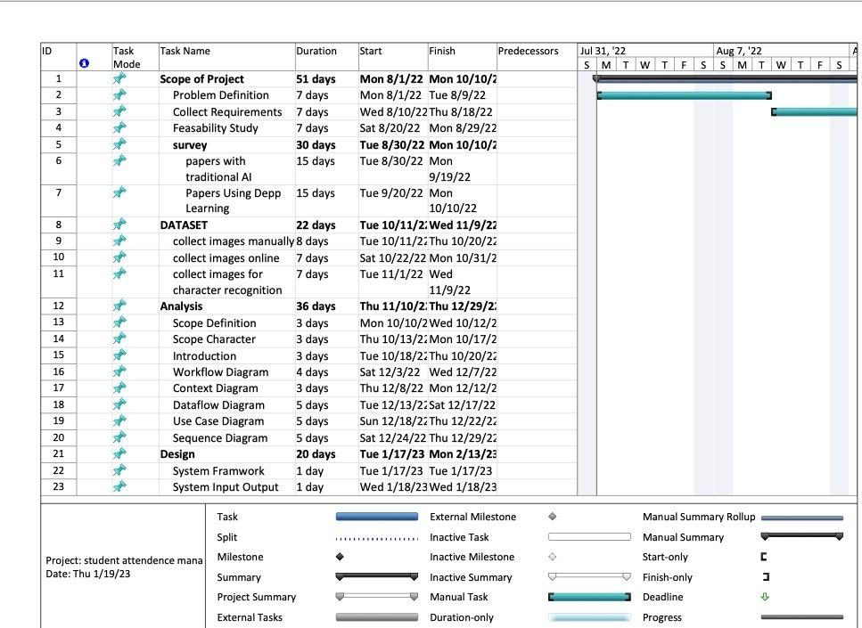

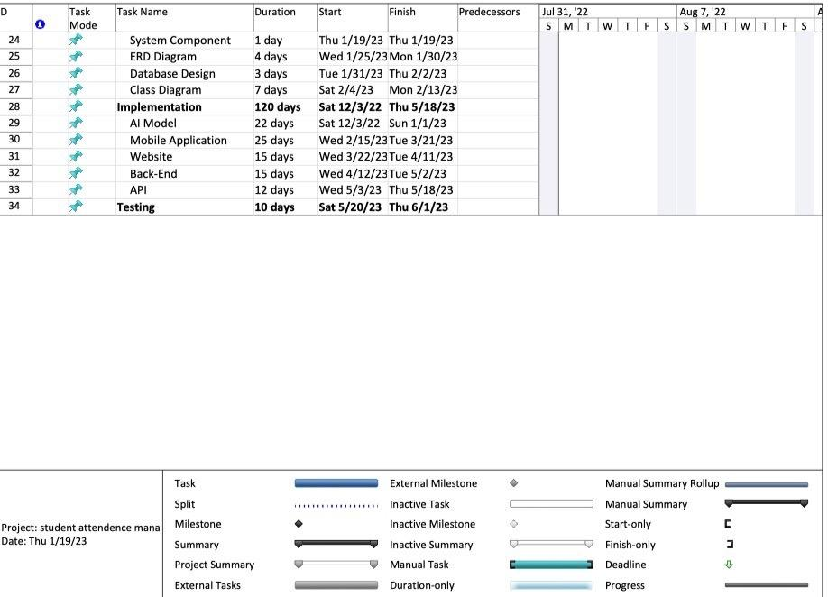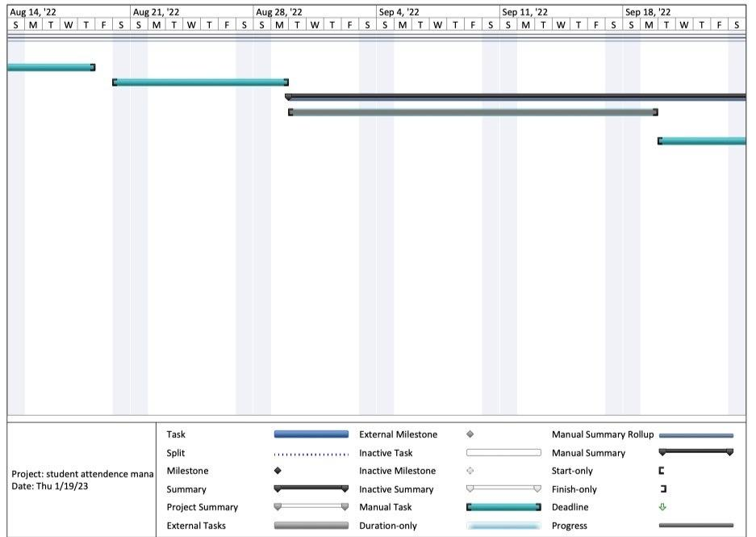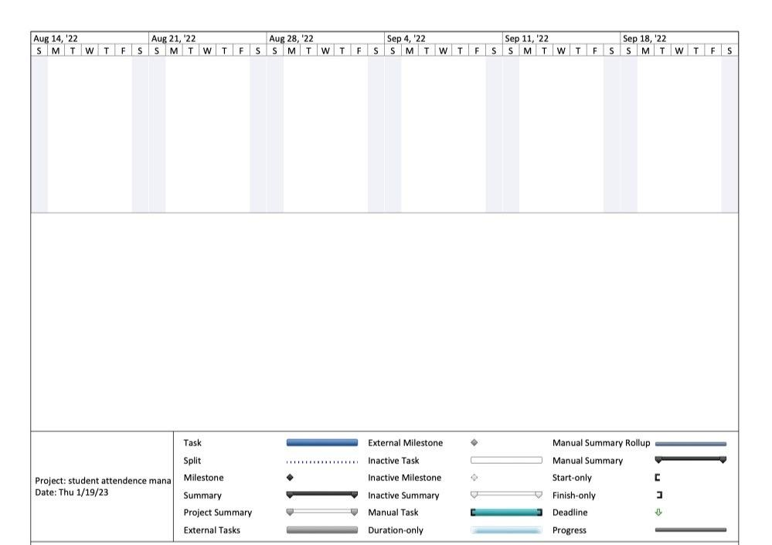

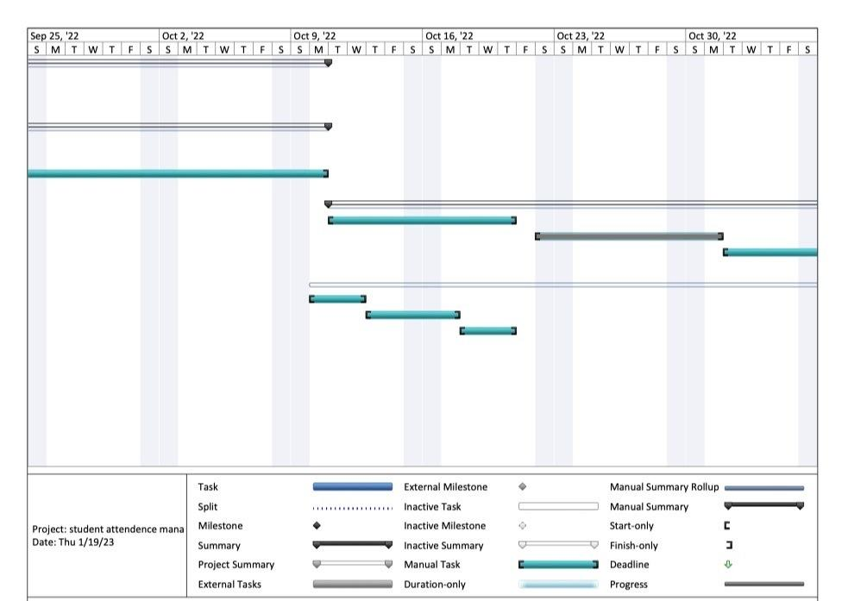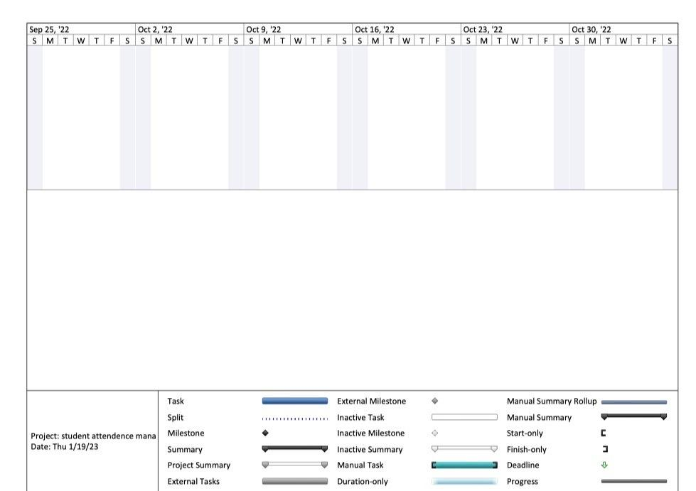

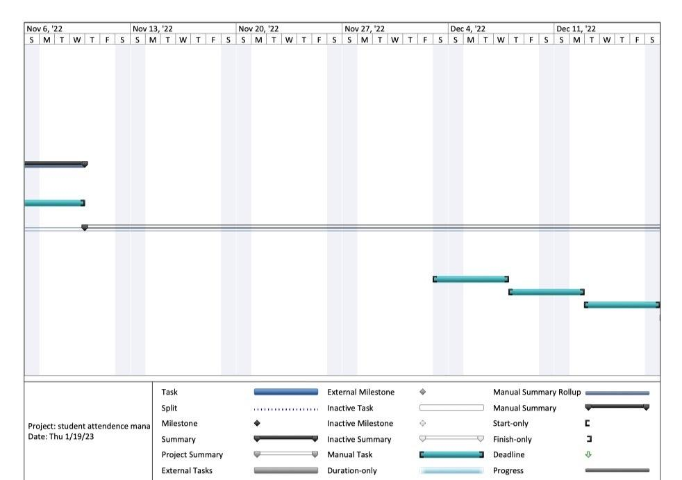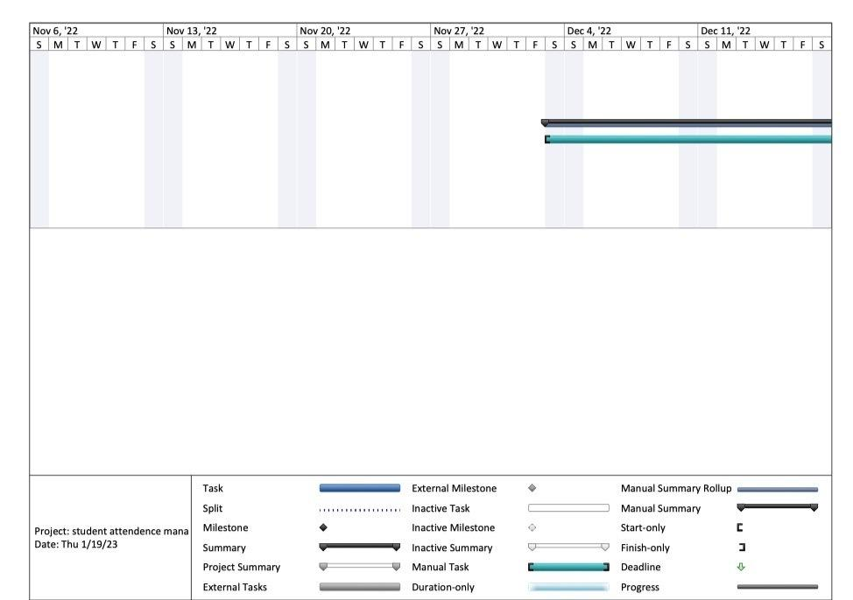

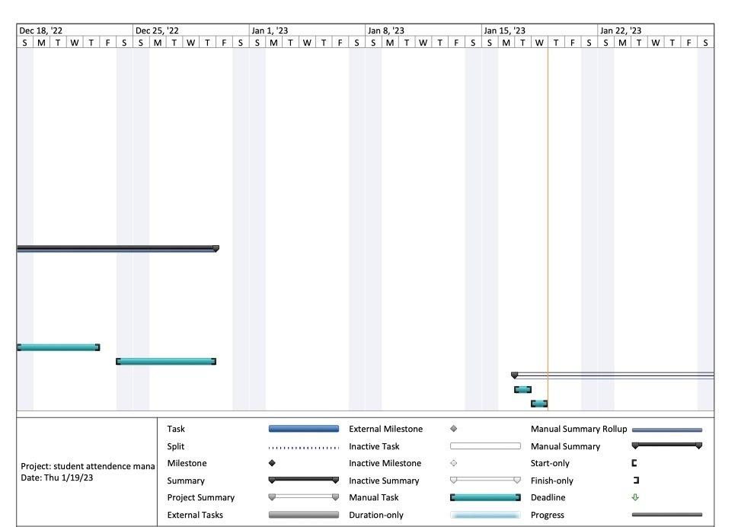

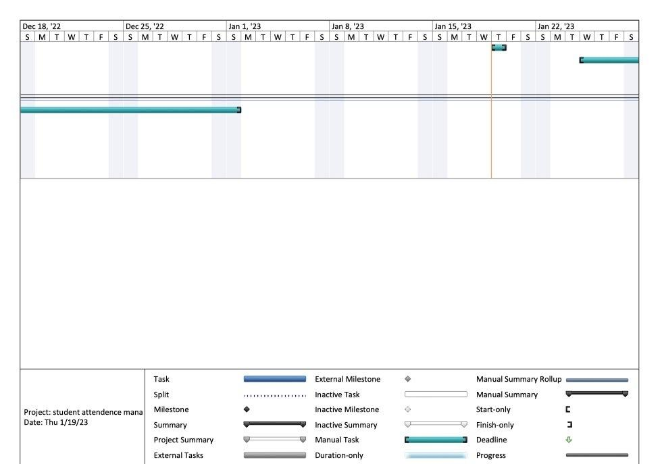

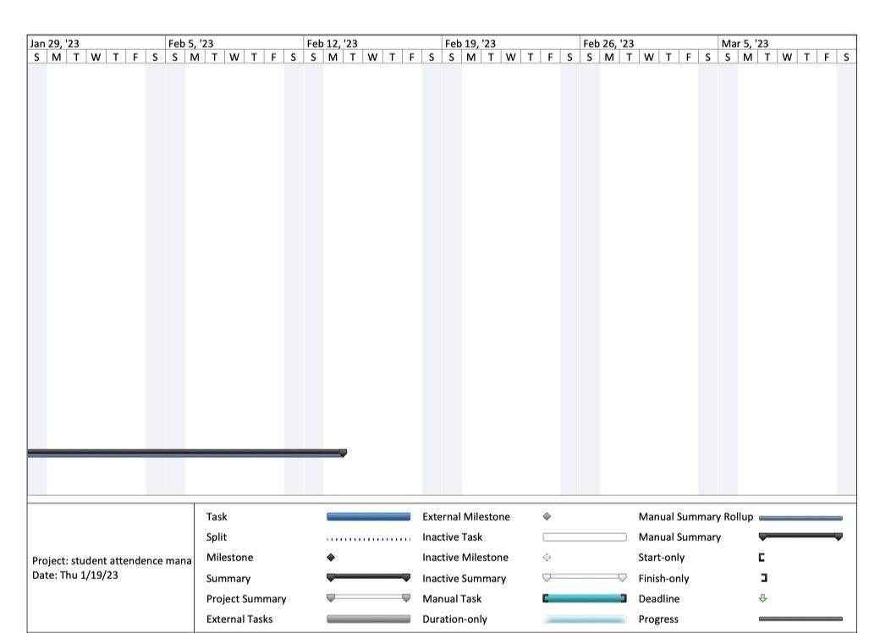

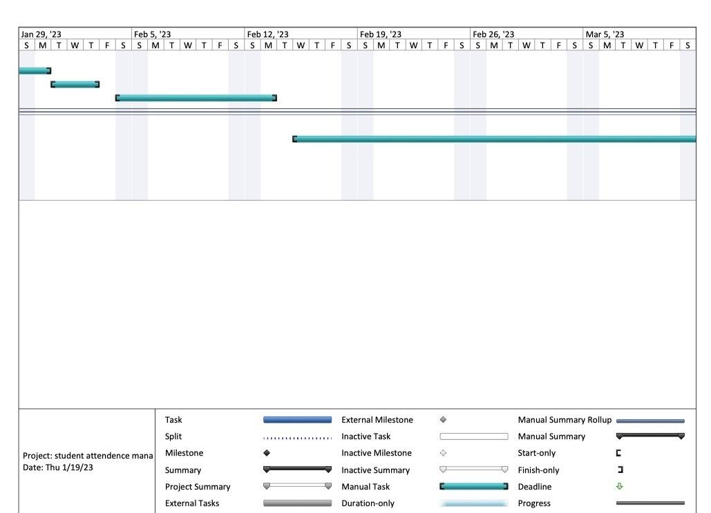

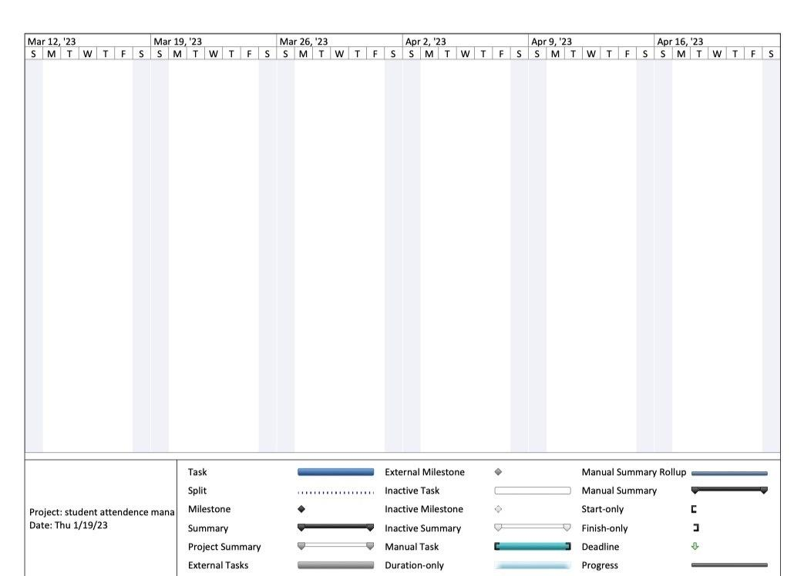

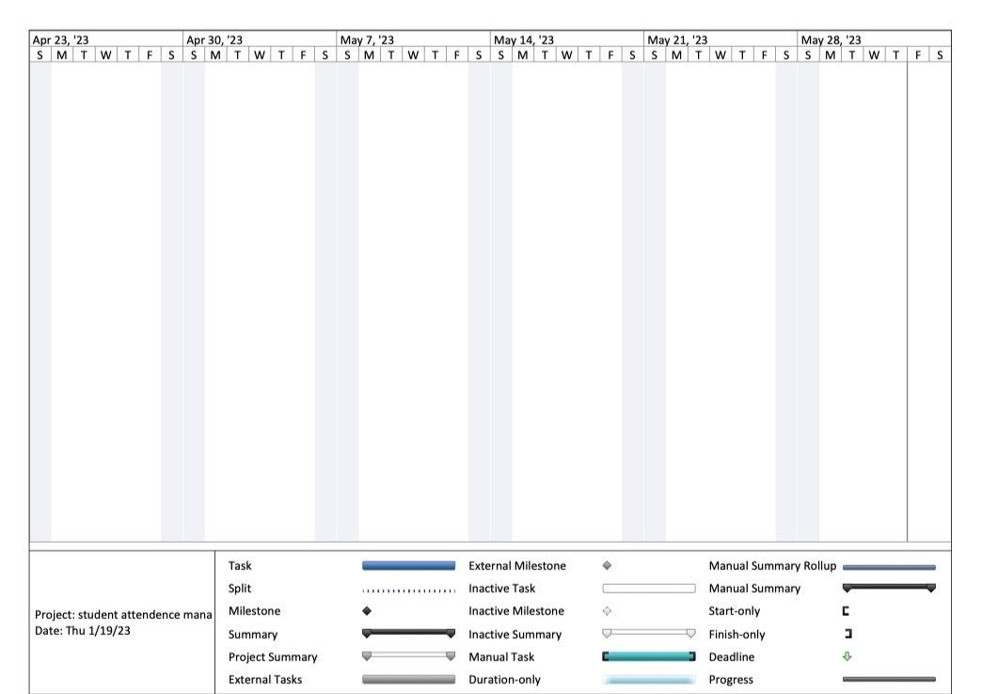

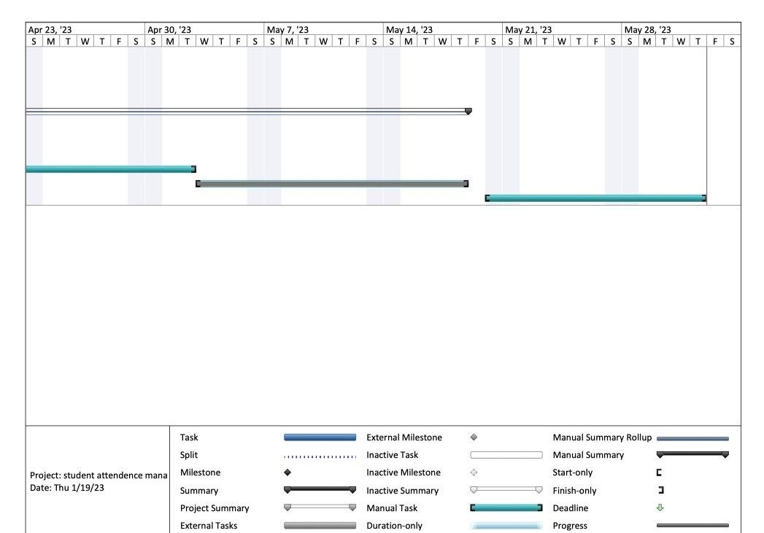

Chapter Three

------------------------------------------------------------------------------------------------------

Related work

**3.1 Overview:**

In this chapter we are talking about the general idea of the project and show the related work researches which are divided into ML and DL, and a table for all researches to describe the important points.

**3.2 General Background:**

The highway fees are taken from cars at the gate which is on the way, that gates waste too much time of the car because every car have to stop at the front of the gate and pay the fee then go, that process make a traffic jam at the gate because of the cars row.

The system we build uses cameras to capture images of cars in the highway then extract the car license plate number and add the fee of the way to the car account on the application that provide the owner to pay from his credit card or any payment method, that will save time of cars on the highway and let them drive at usual speed without stopping.

**3.3 Deep Learning and Traditional Machine Learning:**

**3.3.1 Traditional Machine Learning:**

Ahmed Abdelmoamen Ahmed et al. in [1] proposed automatic number plate recognition (ANPR) which automatically recognizes vehicle number plates using high-speed cameras. After capturing the image, it was converted it to gray scale, then a threshold function was applied for image binarization, followed by, Connected Component Analysis (CCA) for image post processing. Moreover, an image segmentation process was utilized to separates the relevant objects in the image. Finally, k nearest neighbor (KNN) was used as a classier to recognize the plate’s actual characters. The proposed model used more than 160 car images and the model classification accuracy was 95% on testing dataset, the model required around 10 ms only to detect the actual characters in the number plate. The overall processing time 29 ms. the model failed to recognize some characters correctly and confuses characters with similar structures such as D with O, 6 with 8, K with I, etc.

Ayman M. Hassan et al. in [2] proposed a car plate recognition system based on Support Vector Machine (SVM) for a vehicle building entrance. The proposed system consists of two gates (entrance - exit). Firstly, an ultrasonic sensor detects the vehicle existence, then a command to a camera to capture vehicle is sent to an Arduinoboard to control vehicle gates. After image preprocessing, both vertical and horizontal edge detection were used to detect car plate, followed by connected-component labeling to separate each number. Finally, histogram of oriented gradient (HOG) and SVM were used as features and classifier, respectively, to recognize the numbers. A total of 100 car images (70 training – 30 testing) were used to train and test the proposed system. Based on the depicted results, the proposed system achieved an overall accuracy of 83.3% on testing dataset with an overall processing time of 5 seconds. The proposed system failed to localize some car plates or failed in one of the three stages in recognizing plate numbers because the digits were ambiguous.

Manal Alghamdi et al. in [3] presented automatic number plate recognition model of Saudi License Car Plates to solve the problems of traffic regulation and traffic violations facing the society. After the image capturing, the image was preprocessed via a set of steps 1) image conversion to gray scale, 2) image resizing, scaling, and rotation, 3) removing high-frequency noise using Gaussian blurring. Then two threshold image segmentation was used to separates the relevant objects in the image. Finally, optical character recognition (OCR) technology was utilized to turn printed words of the preprocessed images into editable text. The used dataset contains 50 images of various parked cars. The proposed model achieved an accuracy of 92.4% for Arabic and 96% for English texts. The car plate size and location may effect on the performance of the model.

Nur Liyana Yaacob et al. in [4] License plate recognition for campus auto gate system to the university gate. License plate localization: image enhancement, crop and convert it to gray scale, Sobel edge detection, erosion, image closing, image banalization, and locating license plate region. Character segmentation: morphological operations, skew correction, row detection and character segmentation. Character recognition: template matching method is utilized in the character recognition stage. Data set is a total of 95 images were used as the input images, the success rate for the license plate localization, character segmentation and character recognition are 93.68%, 93.25% and 84.33% respectively. the license plate localization performance will be affected if the vehicle has text stickers on the vehicle body or vehicle model written on the front body and if the vehicle has a complex background, for the character segmentation stage, the performance will be affected if the characters are too close to each other, In the character recognition stage, there are some misclassification occurred. Because of the resemblances between the characters.

Fattah Alizadeh and SazanLuqman. in [5] proposed an automatic car plate recognition (ACPR) system that automatically recognizes vehicle number plates using high-speed cameras. After capturing the image, the image was resized to 200*200 pixels, converted to a gray scale and binary one, and then the de-noised. The proposed system utilized Speeded up Robust Features (SURF) descriptor as features for separating the car plate region from the whole image. Then, an image segmentation process was applied to separate the relevant objects in the image, and then the underlying descriptors of the digits later will be compared to those which have already been saved in the dataset. The minimum distance between the target image and the saved ones indicated the digit. Dataset of 200 images which was categorized into 5 groups, in terms of distance from the camera, view angle, alignment, plate color, and weather condition was used to evaluate the proposed system. The images were taken in different locations of the region. The proposed model achieved an accuracy of 94% on testing dataset, when the car plate is 1 Meter far from the camera, the highest accuracy achieved is 94%, but for the 4-meter distance, the localizing and recognition is not satisfactory at all (27%), so the model accuracy depends on the distance between the car and camera in addition to the weather.

**3.3.2 Deep Learning:**

Kuken Raj Pugalenthy et al. in [6] proposed using computer vision to recognize the car plate registration number in order to monitor the vehicle movement. When capture the car image they use NumPy slicing to get right region of interest and make Image Warping, they use YOLOv3 to detect the position of car registration plate and resize images by OpenCV, NMS technique solve the problem on multiple detection and make image thresholding for color inversion, after that use PyTesseract to read the characters from the image and Regular Expression to eliminate the weak predictions from the PyTesseract results. They didn’t mention the dataset, the model achieved 100% accuracy in recognizing. The car registration number makes harder to look in moving motion. So here, fast operation is needed to capture the picture or also make a video out of the captures. the main scope of this paper is to identify and recognize the vehicle registration license plate under normal weather daylight condition.

Mau-Luen Tham et al. In [7] IoT Based License Plate Recognition System Using Deep Learning and Open VINO to recognize Malaysian car plate is attained via transfer learning. the YOLOv4 trained model’s weights file is inputted into the Open VINO toolkit, Node-RED is chosen as it is a lightweight and convenient flow based editor that uses a web browser to build workflows and MQTT as a cloud, before passing the cropped car plate frame to the Tesseract OCR, convert it to gray scale, blurring, thresholding and dilation to Last, character segmentation is enabled by contour function, we adopt the Tesseract OCR for image to-text conversion. The dataset consists of a total of 500 Malaysian car images, which are divided into 80% for training and 20% for validation of the detection model. YOLOv4, together with Tesseract OCR recognize accuracy with 100% detection accuracy and 89.22% OCR accuracy, but High similarity in numbers and shapes may effect on the performance.

TaoufikSaidani et al. in [8] proposed an automatic license plate recognition system, which is an intelligent system based on analyzing visual data to detect and recognize characters in license plates. The proposed system based on the Faster R-CNN improved by adding an adaptive attention network for the segmentation of the license plate to retrieve the numbers and the letters of identification. Moreover, a deconvolution layer at the top of the features extraction network was added to detect the small size of the target license plate. The anchor sizes, scales, and aspect ratios were modified to fit the license plate, speed up the processing speed to achieve real-time conditions by using the Inception v3 model. These plates are from Egypt, KSA, and UAE, because they are similar in their Arabic numbers. The model fails to recognize the plates in difficult weather times of rain and sandy winds, as well as in low light. The model has been developed to be able to process images at speeds up to 23 FPS. the model achieves a recall of 98.65 % and a precision of 97.46 %. We couldn't get dataset public on the internet and I collected it from the streets and python script then it was manually filtered and labeled and it has a size of 6000 images.

Sergio M. Silva and CláudioRosito Jung .in [9] proposed an Automatic License Plate Recognition (ALPR) that automatically recognizes vehicle number plates using high-speed cameras. After capture the image resizing it to 320 × 320 pixels, converting the color image into a grey scale and binary one, and then the de-noising process, use Improved Warped Planar Object Detection Network (IWPOD-NET) that is able to detect the four corners of an LP in a variety of condition from the whole image. They trained two distinct networks, one to detect cars and LPs jointly, and another to perform Optical Character Recognition OCR, for classification they use two distinct CNNs then using YOLOv3 for recognition the car plate. This network was trained with a small amount of annotated data (only 693 images), and showed remarkable generalization to handle both car and motorcycle LPs capture data variety of illumination conditions and viewpoints. tolerances in the string edit distance. For some datasets, the system was not trained to capture strong geometric distortions. The system achieves 100% accuracy, which is also an indirect clue that the LPD module can correctly locate the LP.

**3.4 Deep Learning and Machine Learning (Table [T1]) :**

|  |  |  |  |  |  |
| --- | --- | --- | --- | --- | --- |
| **Study** | **Objectives** | **Methodology** | **Classifier** | **Dataset** | **Performance Measures** |
| **1** | enhance the accuracy of recognizing number plates in real time & time of processing | 1) Using high-speed cameras to capture the car.  2) Convert the image into grayscale one.  3)  Use Threshold function to be a binary image.  4) Use (CCA) for image post processing.  5) Image segmentation process to separate the relevant objects in the image.  6) Enters the feature vector to (KNN) classier to recognize the plate’s actual characters. | KNN | Kaggle & Google Web Scraper (160 Image) | The model classification accuracy is 95% |
| 2 | Design a model for a vehicle building entrance using a license plate recognition algorithm | 1) An ultrasonic sensor detects the vehicle then send a command to a camera to capture vehicle.  2) An Arduinoboard to control vehicle gates.  3) Image Preprocessing to prepare the image (rgb2gray2binary).  4) Use edge detection-vertical and horizontal edge histogram projection to detect car plate.  5) Use connected-component labelling to separate each number.  6) Use (HOG) and SVM to recognize the numbers. | SVM | _ | The model overall accuracy is 83.3% with 30 testing images and 70 training images. |
| 3 | Recognition of Saudi car plates with the use of edge  detection, segmentation, and contouring techniques | **CNN** to detect the language and the country of the LP | Binary K-means | 50 images of various parked cars. | Results in an accuracy of 92.4% for Arabic and 96% for  English texts |
| 4 | Designed to work in an IR sensor is used to detect the motion of the car and the camera will be triggered to capture the vehicle image | License plate detection (LPD)  method | Template matching | 95 images with an 8MP iPhone camera | License plate localization, character segmentation and character recognition are 93.68%, 93.25% and 84.33% respectively |
| 5 | Create an automatic system to detect, extract, segment, and recognize the car plate numbers in the Kurdistan Region of Iraq (KRI) | Speeded Up Robust Features SURF descriptor | _ | 200 images. | accuracy up to 94% |
| 6 | Identify and recognize the vehicle registration license plate under normal weather daylight condition to monitor the vehicle movement | 1) Capture the car image.  2) Use ‘NumPy’ slicing to get right region of interest.  3) Image Warping.  4) Use (YOLOv3) to detect the position of car registration plate.  5) Resize images by OpenCV.  6) Use (NMS) technique for multiple detection.  7) Image thresholding for color inversion.  8) Use (PyTesseract) to read the characters.  9) Use (RGX function) to eliminate the weak predictions. | _ | _ | The model achieved 100% accuracy in recognizing. |
| 7 | Identify and Recognition of  License Plate Recognition System Using Deep  Learning | **CNN-** learned features.  **HOG** feature for detection. | KNN | 500  images | accuracy with 100% detection  accuracy and 89.22% OCR accuracy |
| **8** | Detect and recognize characters in license plate | - Developing an automatic license plate detection system (ALPD) based on the Faster  R-CNN model.  - Improving the performance of the Faster R-CNN model by adding the adaptive attention network and the deconvolution layer.  - Modifying the anchor sizes, scales, and aspect ratios to fit the license plate.  - Speed up the processing speed to achieve real-time conditions by using the Inception v3 model. | _ | 6000 images  Collected by python script and manually filtered | Recall of  98.65 % and a precision of 97.46 % |
| 9 | an automatic system to detect, extract, segment, and recognize the car plate numbers | -Improved Warped Planar Object Detection Network (IWPOD-NET) that is able to detect the four corners of an LP in a variety of condition from the whole image.  -YOLOv3 for recognition the car plate.  - CNN | CNN | 693 images | Accuracy 100% |

**3.5 comparison with related work:**

Salik in Dubai is characterized by allowing vehicles to pass without having to stop in front of gates or stations to pay fees, vehicles

cross the highway at its usual speed without stopping.

The Abu Dhabi Darb application, via smart phones and computers, provides an integrated set of interactive maps and several services.

**3.6 Requirements**

**3.6.1 Functional requirements:**

The functional requirement will describe a particular behavior or function of the system when certain conditions are met and developers must implement them to enable users to accomplish their tasks.

**User   
For users these functions include**

* **Login:** the system must allow the user to log in
* **Payment:** thesystem must allow the user to pay
* **View history:** system shows the history of the car
* **Contact us:** contact with the admin of the system
* **Report stolen:** add report stolen to the system

**Admin**

**For admin these functions include**

* **Control reports:** system reports must contain all reports of users and view the history of the car
* **Database:** system database must contain all related information about the user and his car (**check and approve**)
* **Sign up**: the system must allow to add a new user and sign up

**3.6.2 Non Functional requirements:**

A non-functional requirement (NFR) is a requirement that specifies criteria that can be used to judge the operation of a system, rather than specific behaviors. Non-functional requirements are often called the "quality attributes" of a system.  
Non-Functional requirements such as:

* **Appearance &usability:** simple look and easy-to-use application
* **Availability:** the system must be available at any time
* **Response:** the system is faster in to respond of requests of the user
* **Security:** users’ information should be secure
* **Operational & environmental:** the application shall be used in variable lighting conditions
* **Reliability**: consistency of the system appears in the system being available all the time.

**Scalability**: the ability of the system to handle the growth of data

Chapter Four

------------------------------------------------------------------

Proposed system and all diagrams

**4.1 Overview:**

In this chapter we are talking about the system diagrams of the project like Data Flow Diagram(DFD), Context Diagram, System Framework, Workflow Diagram, Use Case Diagram and Sequence Diagram, the Actors of the system and their interaction with the components.

And also include the requirements that the system must satisfy are of two types, which are the functional and the non-functional requirements.

**4.2 System Framework:**

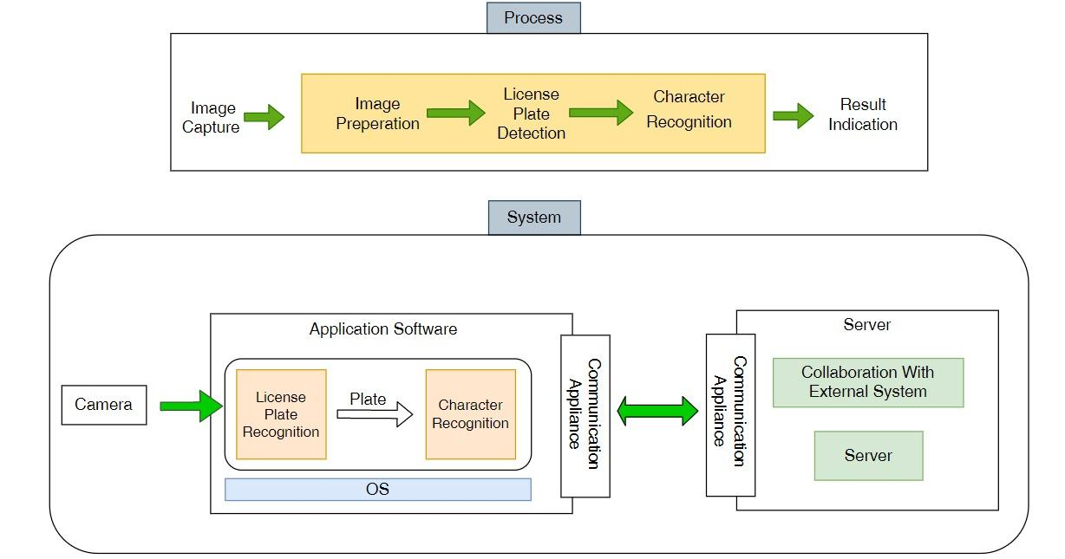

**4.3 Analysis:**

**4.3.1 System Specification Use Case:**

**Use Case Diagram:**

* Use cases represent system functionality from the user’s perspective.
* Use Case diagrams describe who will use the system and in what ways the user expects to interact with the system.
* Use Case diagrams represent the interactions between use cases and actors.
* Use Case diagram represents the interactions between system, external systems, and users.

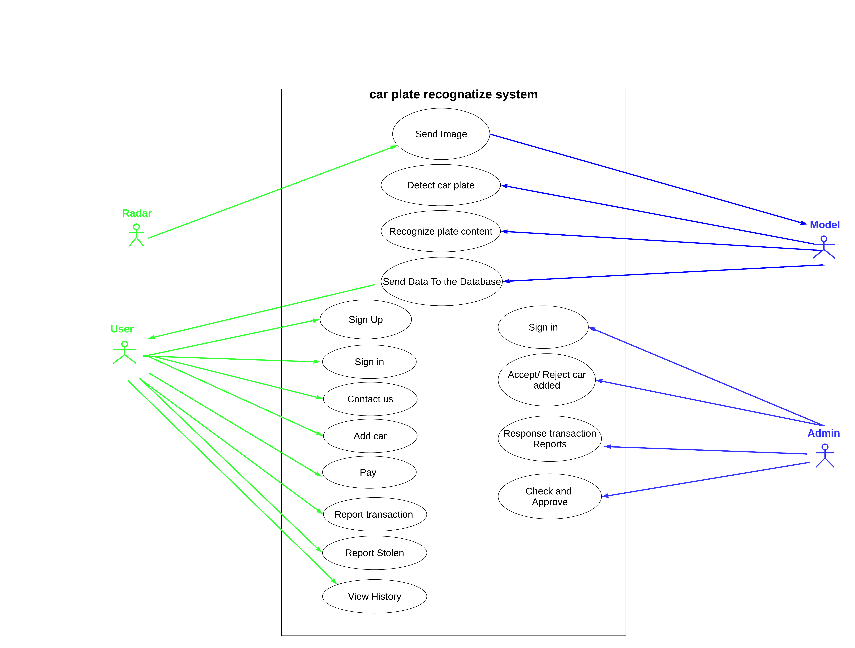

**Use Case Scenario:**

* A use case Scenario represents the sequence of events along with other information that relates to this use case.
* A typical use case specification template includes the following information:

- Primary Actor

- Secondary Actor (if exist)

- include use case (if exist)

- Purpose

- Pre and Post condition

|  |  |
| --- | --- |
| Send Image | Use case Name |
| Radar Camera | Primary Actor |
| Model | Secondary Actor |
| Radar send token image to the model. | Purpose |
| Radar took an image | Pre-conditions |
| The model Receives the image and processes it. | Post-conditions |

|  |  |
| --- | --- |
| Detect User Information | Use case Name |
| Model | Primary Actor |
| The model process the image and illustrate the required details of the image. | Purpose |
| The model has an image to process it. | Pre-conditions |
| the image details save in the server of the model. | Post-conditions |

|  |  |
| --- | --- |
| Send data to the system | Use case Name |
| Model | Primary Actor |
| user | Secondary Actor |
| The model sends the car details to the user account in the system.. | Purpose |
| The model must have the image details that have been processed. | Pre-conditions |
| The image details saved in user account in the system. | Post-conditions |

|  |  |
| --- | --- |
| Sign Up | Use case Name |
| Admin | Primary Actor |
| Admin add user access information to the system. | Purpose |
| Admin have the user information. | Pre-conditions |
| User's information will be added to the system. | Post-conditions |

|  |  |
| --- | --- |
| Sign in | Use case Name |
| User | Primary Actor |
| User enter to the system using his sign in information. | Purpose |
| Authentication: To authenticate if a user's information is in the system or not. | Include use case |
| User has the right information to get into the system. | Pre-conditions |
| Get Access to the system successfully. | Post-conditions |

|  |  |
| --- | --- |
| Contact Us | Use case Name |
| User | Primary Actor |
| User can send report about.his problem. | Purpose |
| User must be logged to the system. | Pre-conditions |
| The report will be sent to the system.. | Post-conditions |

|  |  |
| --- | --- |
| Response Reports | Use case Name |
| Admin | Primary Actor |
| Admin can response to the reports of the users.. | Purpose |
| There are some reports to deal with it. | Pre-conditions |
| Send feedback to the user's reports. | Post-conditions |

|  |  |
| --- | --- |
| Pay | Use case Name |
| User | Primary Actor |
| User can pay his fines using pay function. | Purpose |
| Pay method: user choose how he will pay for the fine | Include Use case |
| There is a fine in the user's account. | Pre-conditions |
| The fine is canceled after the payment. | Post-conditions |

|  |  |
| --- | --- |
| Report Stolen | Use case Name |
| User | Primary Actor |
| User can report the system about his stolen car. | Purpose |
| His car was stolen. | Pre-conditions |
| If the report approved by the system it will send a warning to the road patrols | Post-conditions |

|  |  |
| --- | --- |
| Check and Approve | Use case Name |
| Admin | Primary Actor |
| Admin check if the user's report for stolen car true or by mistake, if true then approve the report.. | Purpose |
| There is a report about stolen car and check if the report right or wrong. | Pre-conditions |
| If the report was right the admin will approve the stolen report. | Post-conditions |

|  |  |
| --- | --- |
| View History | Use case Name |
| User | Primary Actor |
| User can view his historical fines. | Purpose |
| User must be logged into the system. | Pre-conditions |
| Details of the fines will e viewed to the user. | Post-conditions |

**4.3.2 Context Diagram:**

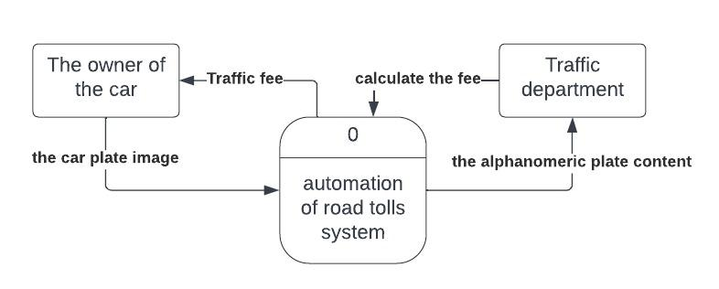

**4.3.3 Data Flow Diagram:**

**System Flow: 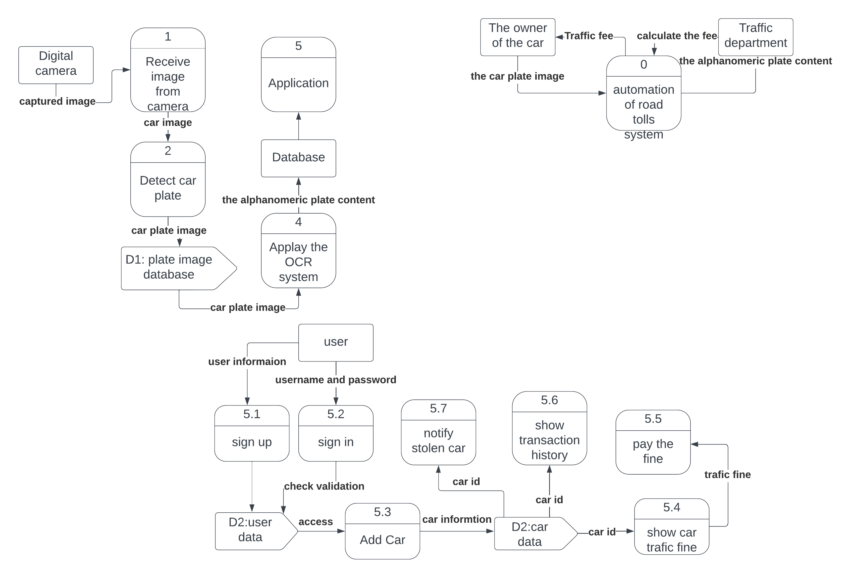Application flow:** 

**4.3.4 Workflow Diagram:** 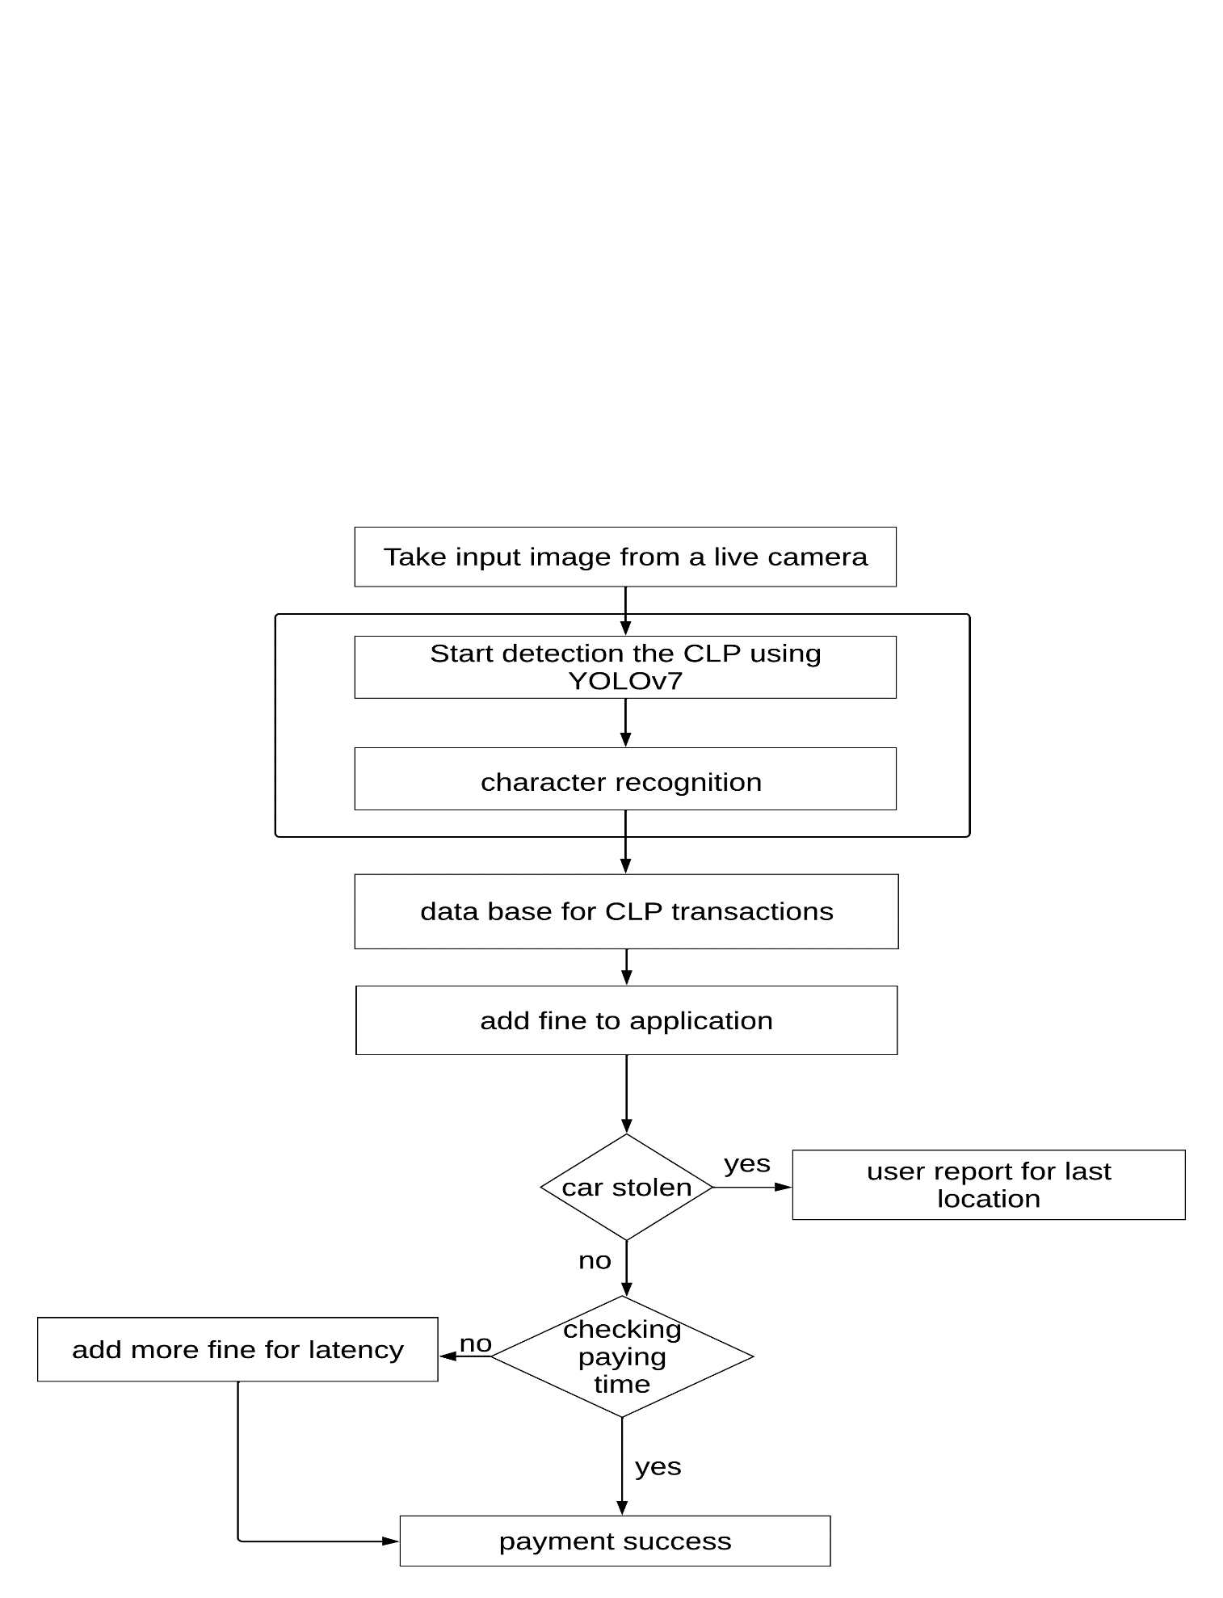

**4.4 Design:**

**4.4.1 System Sequence Diagram:**

A sequence diagram is a type of interaction diagram because it describes how -and in what order- a group of objects works together. These diagrams are used by software developers and business professionals to understand requirements for a new system or to document an existing process.

In the following section we display Sequence Diagram of system:

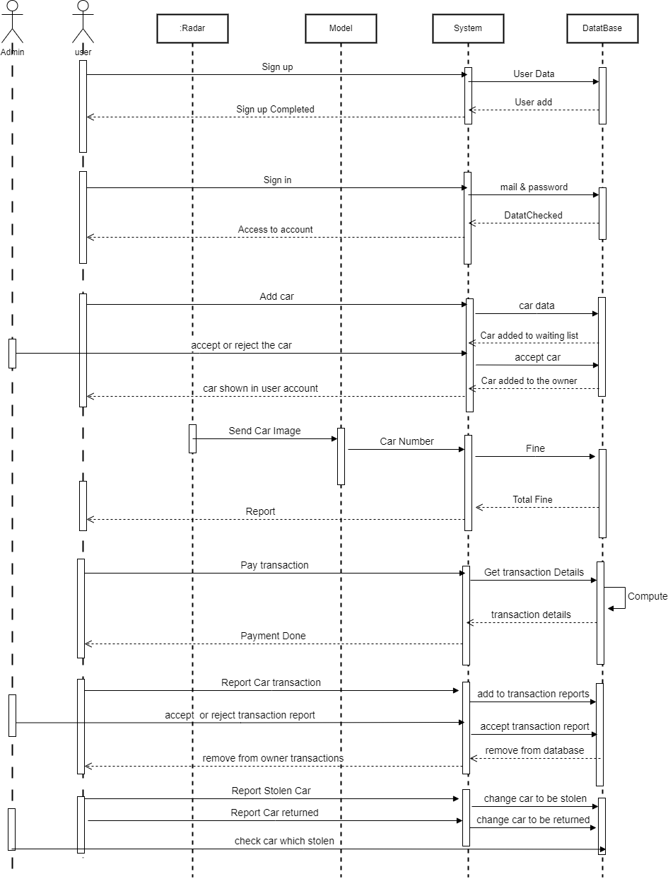

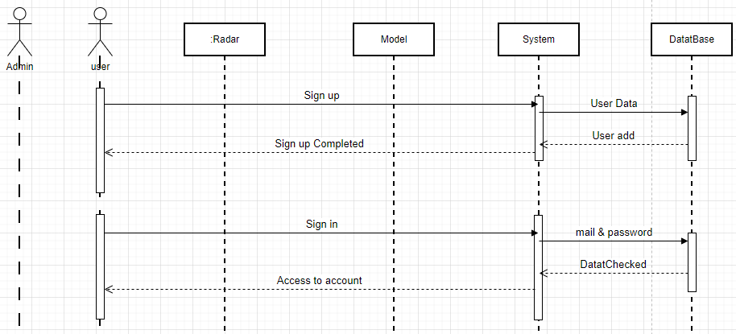

User can sign up to the system by add all information required then the system add them at the database to be a new user.

User can enter the system by signing in with his mail and password as he will send the info to the system then the system sends it to the database to check if this data is true or not and this user is in the system or not to give access to him.

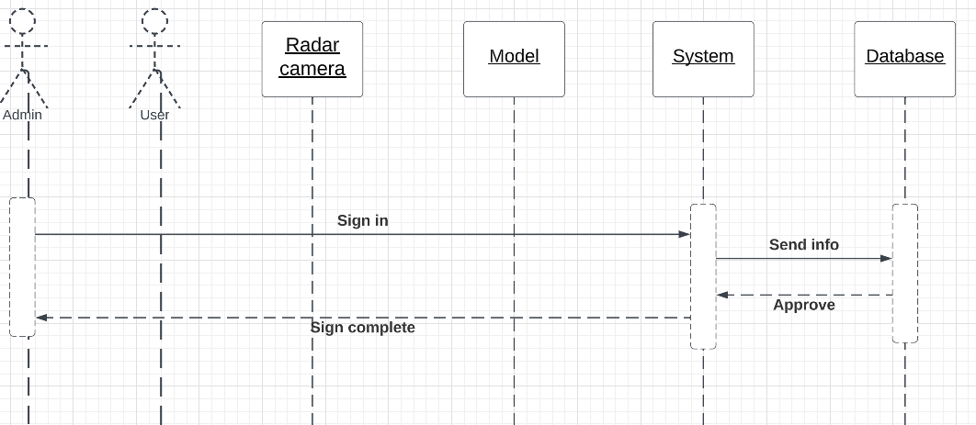

Admin of the system can sign in into the system by sending the information and then the info will be stored in the database.

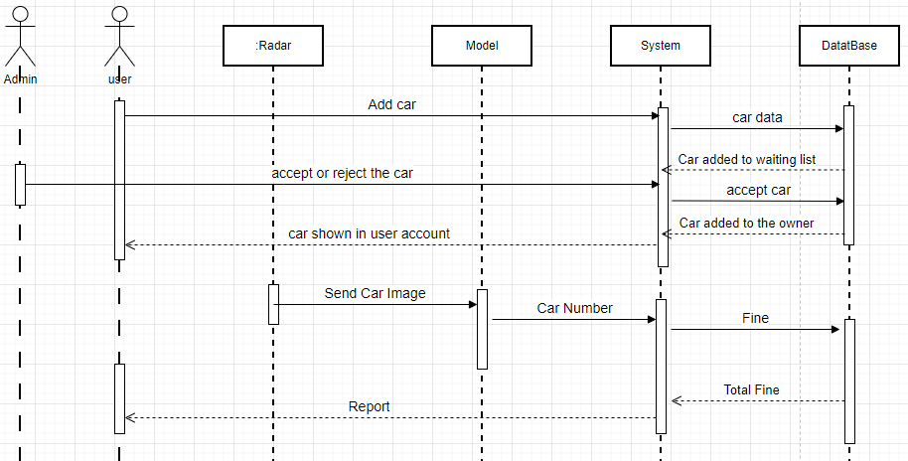

User can add a new car to his account by add all required information to the system and then the car need to be approved by the admin to add in the user.

Radar Camera sends the photo that taken from the gate to the model, the model will be able to get the photo in addition to doing some processes to it and the model detect the car plate license numbers moreover send it to the system to detect the user information and adding the suitable fine to him then store it into the database, finally the system will send report contains the fine and details to the user.

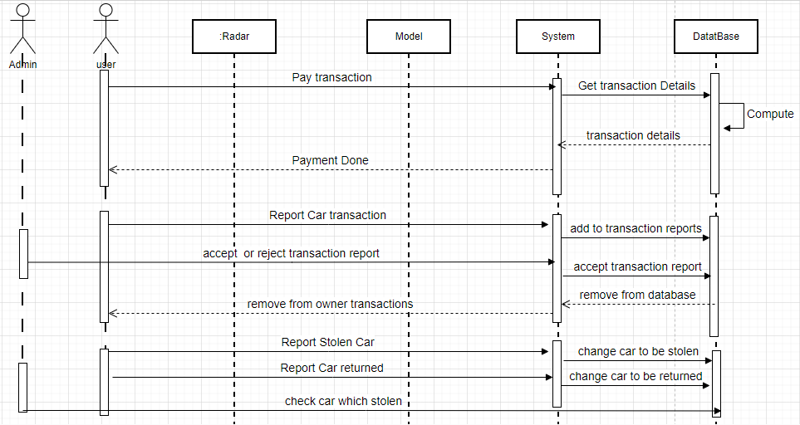

User can pay his fine by enter the system and send a request of paying, system send a request to the database to get the fine details, then the database compute the total fine and send it to the system, after that the user can complete the payment successfully.

If the user doubt that the transaction didn’t belong to him he can make a report to that transaction and the admin will see if it belongs to him or not and if not, he will remove the transaction from the user is list.

User can report that his car is stolen and all stolen cars appear in a list in the admin to can contact with police to told them. If the car is returned the user can change the car from stolen to returned.

Chapter Five

------------------------------------------------------------------------------------------------------

Fast Pass System

**5.1 System overview:**

In this section, we present our innovative system for automated car identification and fee collection, eliminating the need for traditional toll gates on the road. The proposed system comprises two primary modules.

**5.1.1 The first module:** is the vehicle identification module, which uses advanced image processing and computer vision techniques to accurately identify and classify cars.

**5.1.2 The second module:** focuses on fee collection, achieved through a program or a website interface. This module enables users to register their vehicles and payment information, allowing for manually deduction of toll fees based on the identified vehicles. By secure payment gateways, the system ensures a streamlined and hassle-free payment process for users.

The fundamental concept behind this system is to enhance the efficiency of toll collection by leveraging cutting-edge technology, thus eliminating the need for physical toll gates on the road.

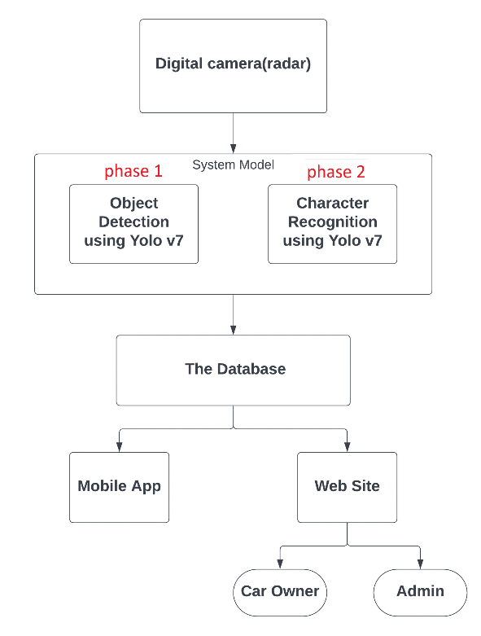This approach not only improves convenience for drivers but also minimizes traffic congestion and enhances overall road efficiency.

**5.2 System Model:**

- In this phase, an object detector is an object detection algorithm that performs image recognition tasks by taking an image as input and then predicting bounding boxes and class probabilities for each object in the image. Most algorithms use a convolutional neural network (CNN) to extract features from the image to predict the probability of learned classes.

- The newest YOLO algorithm surpasses all previous object detection models and YOLO versions in both speed and accuracy. It requires several times cheaper hardware than other neural networks and can be trained much faster on small datasets without any pre-trained weights. Hence, YOLOv7 is expected to become the industry standard for object detection in the near future, surpassing the previous state-of-the-art for real-time applications.

**5.2.1 What is YOLO in computer vision?**

- YOLO stands for “You Only Look Once”; it is a popular family of real-time object detection algorithms. The original YOLO object detector was first released in 2015. At release, this architecture was much faster than other object detectors and became state-of-the-art for real-time computer vision applications. Since then, different versions and variants of YOLO have been proposed, each providing a significant increase in performance and efficiency.

**5.2.2 What is YOLOv7?**

- The YOLO (You Only Look Once) v7 model is in the family of YOLO models. In a YOLO model, image frames are featurized through a backbone. These features are combined and mixed in the neck, and then they are passed along to the head of the network YOLO predicts the locations and classes of objects around which bounding boxes should be drawn. YOLOv7 conducts a post-processing via non-maximum supression (NMS) to arrive at its final prediction.

**5.2.3Why we use YOLOv7?**

The YOLOv7 performance was evaluated based on previous YOLO versions (YOLOv4 and YOLOv5) and YOLOR as baselines. The models were trained with the same settings. The new YOLOv7 shows the best speed-to-accuracy balance compared to state-of-the-art object detectors. In general, YOLOv7 surpasses all previous object detectors in terms of both speed and accuracy, ranging from 5 FPS to as much as 160 FPS. The YOLO v7 algorithm achieves the highest accuracy among all other real-time object detection models – while achieving 30 FPS or higher using a GPU V100.

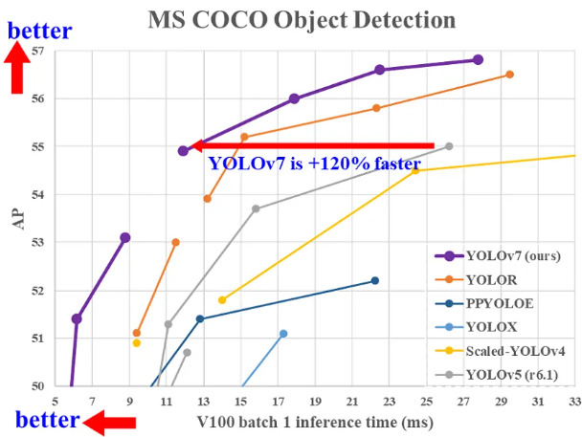

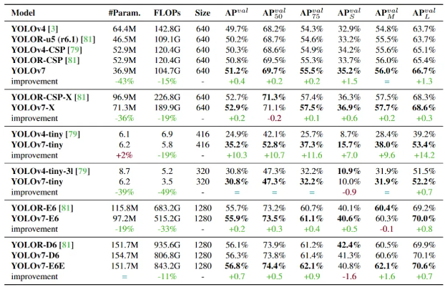*YOLOv7 outperforms: YOLOR, YOLOX, Scaled-YOLOv4, YOLOv5, DETR, Deformable DETR, DINO-5scale-R50, ViT-Adapter-B and many other object detectors in speed and accuracy*.

**Anatomy of the YOLO Detector**

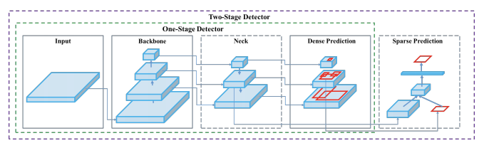

- All object detectors take an image in for **input** and compress features down through a convolutional neural network [**backbone**](https://blog.roboflow.com/glossary/#:~:text=backbone). In [**image classification**](https://models.roboflow.com/classification?ref=blog.roboflow.com), these backbones are the end of the network and prediction can be made off of them. In [**object detection**](https://models.roboflow.com/object-detection?ref=blog.roboflow.com), multiple bounding boxes need to be drawn around images along with classification, so the feature layers of the convolutional backbone need to be mixed and held up in light of one another. The combination of backbone feature layers happens in **the neck.**

- It is also useful to split object detectors into two categories: one-stage detectors and two stage detectors. Detection happens in the **head**. Two-stage detectors decouple the task of object localization and classification for each bounding box. One-stage detectors make the predictions for object localization and classification at the same time. YOLO is a one-stage detector, hence, You Only Look Once.

**5.2.4 YOLOv7 Architecture:**

- The YOLOv7 architecture is based on previous YOLO model architectures, namely YOLOv4, ScaledYOLOv4, andYOLO-R. When designing an efficient network, the designers often consider optimizing no more than several parameters, the number of computations, and the computational density.

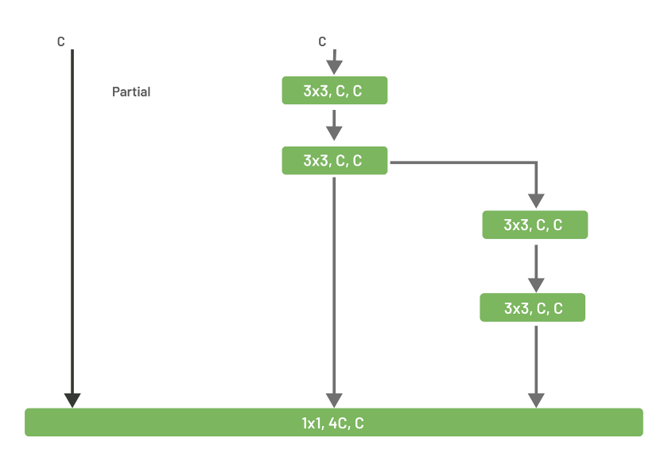- YOLOv7 architecture design is based on ELAN (efficient layer aggregation network). ELAN considers designing an efficient network by controlling the shortest and the longest gradient path, so that deeper networks can converge and learn effectively.

In the diagram, input is directly fed into the bottom block with 1x1 convolution, while two other connections to the block were obtained by convolving the input with 2 and 4 blocks of 3x3 convolution with the same channel multiplier. At the bottom block, all the features are concatenated, and 1x1 convolution is applied to learn rich information.

YOLOv7 modifies the ELAN architecture, called E-ELAN (extended efficient layer aggregation network). ELAN uses expand, shuffle, and merge cardinality to improve the model learning ability without destroying gradient flow paths. As for the architecture, it only modifies the architecture in the computational block, while the architecture remains the same as ELAN in the transition layer. E-ELAN uses group convolution to expand the channels and cardinality of the computational block. It applies the same channel multiplier and group parameter to all the computational blocks in a computation layer. The feature map from each computational block will be shuffled into group size g and then concatenated together. Finally, a shuffled 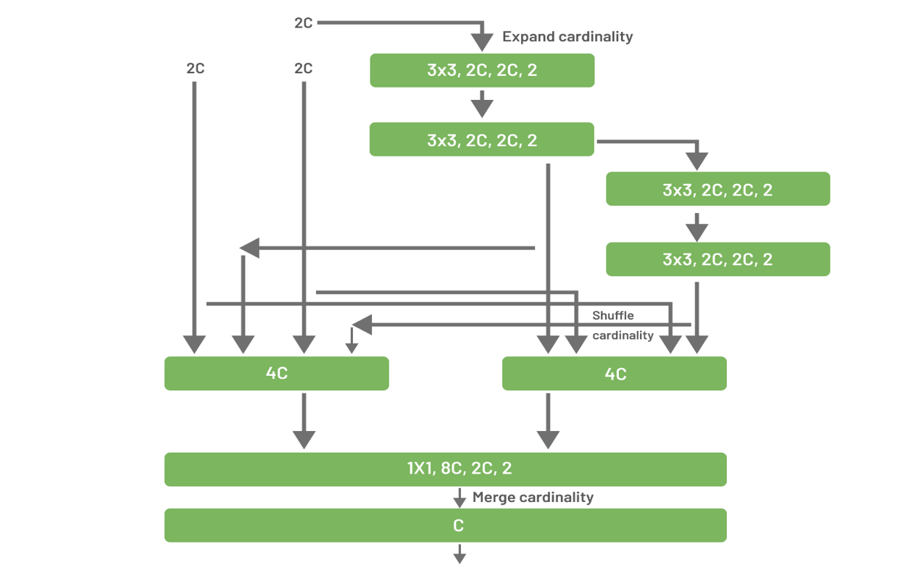group feature map will be added to perform merge cardinality.

**5.3 System Model Phase (1): Object Detection using Yolov7.**

- We collected 673 images of cars, and in order enlarge the training dataset via generating new samples similar to the original training samples, data augmentation was applied

we split them into train (517) and validation (156) dataset, on the trained dataset we used LabelImg for annotating the car license plate, then train Yolov7 with our data. When we use the model it detects the CLP and cut the boundary box to produce car plate image can be used in the next step.

**5.4 System Model Phase (2): Character Recognition using Yolov7:**

- In this phase, we use Yolov7 to recognize the characters and numbers on the CLP image, we have a dataset of some characters and numbers that have their boundary box and we classified them in many classes.

- The dataset was 1983 image split into train (1767) and validation (216) they consists of characters [أ-ب-ج-د-ر-س-ص-ط-ع-ف-ق-ل-م-ن-ه-و-ى] and numbers [1-2-3-4-5-6-7-8-9].

- The model now can recognize the content of the CLP and add it to the database to add the fee to the car owner.

**5.5 The database:**

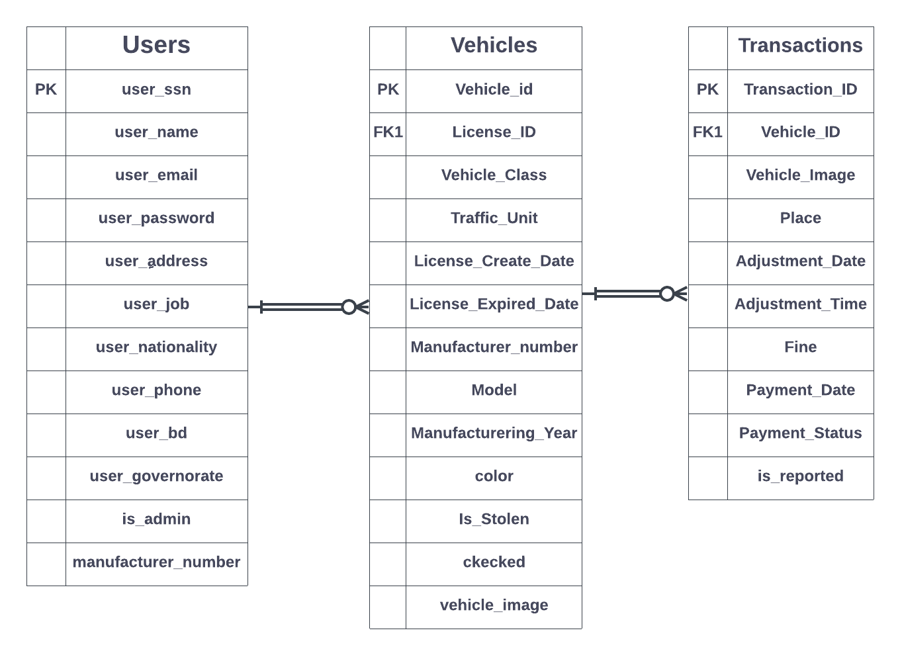

In this phase, our database consists of three table first one for user and there are two users types (in web site only) the car/cars owner and the admin. The second table is vehicles and the owner can have many cars. The last one is transactions for ever car.

**5.6 Mobile App:**

In this phase, the interface of mobile app is developed with flutter and we connect it with the dataset using API developed by Node js. The mobile app is used by the owner of the car only and lets him make some functions.

1-sign in, 2-log in, 3-add car,

4-pay the car fees, 5-report car stolen, 6-contact us,

7-check transactions history.

All these functions will facilitate the payment process for the owner.

**5.7 Web Site:**

In this phase, the frontend of Web site is developed with React js and we connect it with the backend developed by Node js. The web site is used by the owner of the car and the admin lets them make some functions.

The owner of the car has the same functions in the mobile app.

The admin has some functions

1- Give the approve to the car which add by the owner

2-Response reports of the transactions and check if true or not

3-Replay for any contact us questions

Chapter Six

------------------------------------------------------------------------------------------------------

Experimental & Results

**6.1 overview:**

- This section presents and discusses all the details related to the experiments carried out to investigate and evaluate the performance of the proposed car plate detection and plate characters recognition.

**6.2 DATASETS:**

- The Car Images Dataset was collected, comprising a variety of car images containing license plates.

- Each image in the dataset was annotated with bounding box coordinates around the license plate region and the corresponding characters within the plate.

- Before training the car plate detection, image augmentation techniques were applied to the dataset.

- Image augmentation helps increase the diversity and robustness of the training data and in an attempt to simulate the environmental conditions that may affect the stereotyped image of a license plate, some effects have been applied such as: bounding box rotations, Gaussian noise, bounding box blur and brightness(high-low).

- Augmentation helps the system generalize better by exposing it to a wider range of variations that can occur in real-world scenarios.

- Collecting the dataset:

* 650 images collected by taking pictures using some mobile devices.
* The rest of the dataset we use it from the project “**Egyptian Automatic License Plate Recognition (EALPR) dataset” author={Youssef, Ahmed Ramadan and Sayed, Fawzya Ramadan and Ali, Abdelmgeid Ameen}** [**ahmedramadan96/EALPR: A New Benchmark Dataset for Egyptian License Plate Detection and Recognition (github.com)**](https://github.com/ahmedramadan96/EALPR).

**Table 4. Dataset**

|  |  |  |  |  |
| --- | --- | --- | --- | --- |
| NO. | Dataset | No. images | Image size | No. Classes |
| 1 | Plate  Detection | **3080**  - 2765 Training  - 315 Validation | 640x640 | 1 |
| 2 | Character Recognition | **1983**  - 1767 Training  - 216 validation | 640x640 | 26 |

**6.3 EVALUATION METRICS:**

- To evaluate the proposed car plate detection and Plate Characters Recognition, dataset is randomly split into 90% and 10% of the samples as the training set and validation set.

- The performance is evaluated by some of metrics on the validation set, including:

* Confusion Matrix:

- It’s a summary of prediction results on a classification problem.

- The number of correct and incorrect predictions are summarized with count values and broken down by each class.

* Recall: This is the fraction of ground truth objects that are correctly detected by the model. *Recall*(*Sensitivity*) = $\frac{TP}{TP+FN}$
* Precision: This is the fraction of detected objects that are actually ground truth objects. *Precision* = $\frac{TP}{TP+FP}$
* F1 Score: It finds the most optimal confidence score threshold where precision and recall give the highest F1 score. The F1 score calculates the balance between precision and recall.

*F1 Score* = $\frac{2 × Precision ×Recall}{Precision + Recall}$

* AP (Average Precision): This is the most common metric used to measure the accuracy of object detection models. AP is calculated by averaging the precision and recall scores at different intersection over union (IoU) thresholds.
* mAP (mean Average Precision): This is the average AP across a set of IoU thresholds. The mAP is calculated by finding Average Precision(AP) for each class and then average over a number of classes.

*mAP* = $\frac{1}{N} \sum_{i=1}^{N}{{AP}_{i}}$

**6.4 EVALUATION & RESULTS:**

|  |  |  |  |  |
| --- | --- | --- | --- | --- |
| Model | mAP  (Accuracy) | Precision | Recall | F1 Score |
| Car Plate Detection | **%98.8** | **%96.6** | **%96.6** | **%96.6** |
| Plate Character Recognition | **%97.9** | **%94.8** | **%98.9** | **%96.8** |

|  |  |  |
| --- | --- | --- |
| matrix | Car Plate Detection | Plate Character Recognition |
| Confusion Matrix | **­­­­­­­­­­­­­­­­­** |  |
| Precision | **The precision matrix demonstrates high accuracy and precision in object detection tasks, making it an effective model for real-time detection and localization with minimal false positives.** | **The precision matrix for the multi-class YOLOv7 model demonstrates strong accuracy and precision in detecting and classifying objects across multiple classes, showcasing its ability to provide reliable and precise predictions for complex and diverse object recognition tasks.** |
|  |  |  |
| Recall | **The Recall matrix showcases excellent sensitivity and recall rates, enabling the model to effectively capture a significant portion of relevant objects in the detection process, making it reliable for comprehensive object detection tasks.** | **The Recall matrix for the multi-class YOLOv7 model highlights its high sensitivity and recall rates, ensuring that a significant proportion of objects across multiple classes are successfully detected and identified, making it a dependable choice for comprehensive multi-class object detection tasks.** |
| F1 Score | **The F1 Score matrix for YOLOv7 reflects a balanced performance between precision and recall, indicating the model's ability to achieve accurate object detection while minimizing false positives and false negatives, making it a robust choice for various object recognition applications.** | **The F1 Score matrix for the multi-class YOLOv7 model demonstrates a harmonious balance between precision and recall across multiple classes, indicating its ability to provide accurate and reliable predictions while effectively capturing a wide range of objects, making it a strong contender for diverse multi-class object recognition applications.** |

**6.5 Comparison between others systems**

|  |  |  |  |
| --- | --- | --- | --- |
| **Study** | **Crack**  **RFID LPD ANPR GPS** | **Feature** | **Results** |
| **Fast Pass** | x √ √ x | * Using license plate detection and automatic number plate recognition without any need for RFID without any previous equipment * Multiple payment options, including mobile apps and electronic payment systems |  |
| **Darb** | √ x x √ | * Real-time traffic information and alerts * Integration with other transport systems to provide seamless travel experiences * Multiple payment options, including mobile apps and electronic payment systems * RFID technology for automatic toll collection * Analytical tools for traffic management and optimization | **Working in Abu Dhabi** |
| **Salik** | √ x x x | * Automatic toll collection using RFID technology * Multiple payment options, including mobile apps and electronic payment systems | **Working in Dubai** |
| **E-ZPass** | √ x x x | * Automatic toll collection using RFID technology * Multiple payment options, including mobile apps and electronic payment systems * Integration with other transport systems to provide seamless travel experiences | **Working in USA** |
| **Auto-Pass** | √ √ √ x | * Automatic toll collection using RFID technology and license plate recognition * Multiple payment options, including mobile apps and electronic payment systems * Integration with other transport systems to provide seamless travel experiences | **Working in Norway** |

**6.6 Conclusion and Future Work**

* **Conclusion:**

The system for paying road car gate fees using an application, without the need to physically stop at the gate, is a highly efficient and beneficial solution. By leveraging the advanced YOLOv7 model for car plate detection and for accurate character and number recognition, the system has achieved accuracy rates of 98.8% and 97.9%, respectively.

This system offers advantages to both the drivers and the transportation authorities. Firstly, it significantly reduces traffic congestion and waiting times at toll gates, as vehicles can seamlessly pass through without having to halt for payment. This streamlined process leads to smoother traffic flow, minimizes the chances of accidents, and reduces overall travel time for commuters. Secondly, the integration of the YOLOv7 model for car plate detection ensures that the plate detection process is reliable. By accurately identifying the vehicle plates, the system can effectively associate each transaction with the corresponding vehicle, preventing fraud and misuse. Moreover, the high accuracy achieved by the plate recognition model guarantees that the correct amount is charged for each vehicle based on its unique plate number. This prevents any potential revenue losses and ensures fair and transparent payment processing.

Additionally, the implementation of such a system promotes the advancement of artificial intelligence technologies in practical applications, fostering innovation in the transportation industry. As AI models continue to improve and evolve, this system can serve as a blueprint for similar solutions in various other sectors, contributing to the growth of automation and efficiency in different domains.

* **Future Work:**

1. making the payment by providing such a means of payment to facilitate the drivers.
2. We can also integrate this system into state agencies to track and trace stolen vehicles.
3. paying car fines through the application and provide the necessary licenses for the car.
4. After calculating the weight of the transport vehicles passing through the gate, this fee will be added to the application for the driver to pay.
5. If the car is stolen, I will be able to recognize the driver's face.
6. In the event that the car breaks down on the road, the driver can open the application and inform the competent authorities of his condition in order to complete his assistance.

Chapter Seven

------------------------------------------------------------------------------------------------------

Help Desk of the System

**7.1 Web application forms:**

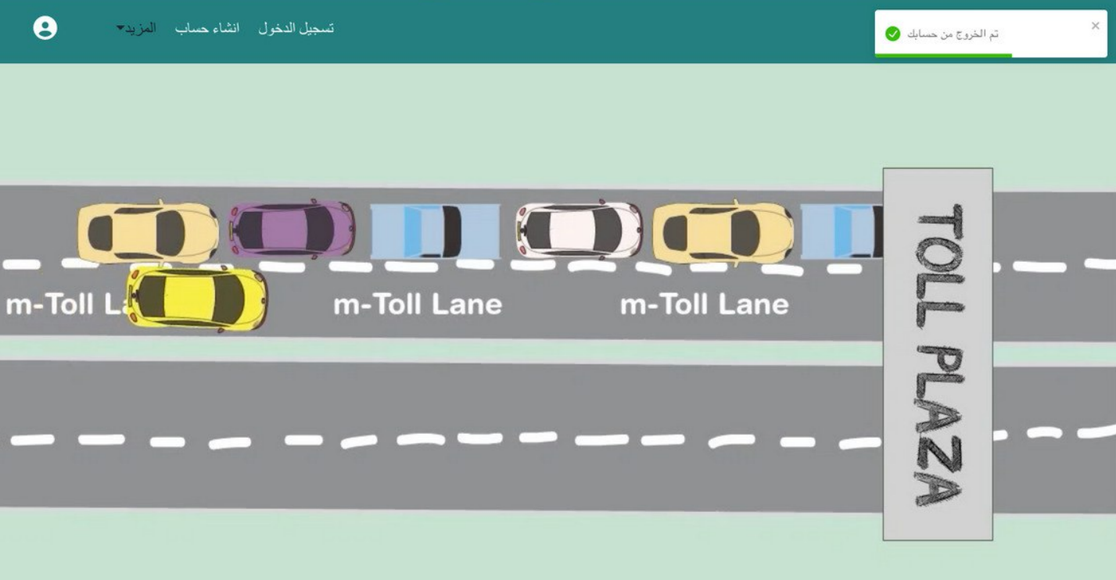

**Home page >> log in / sign up**

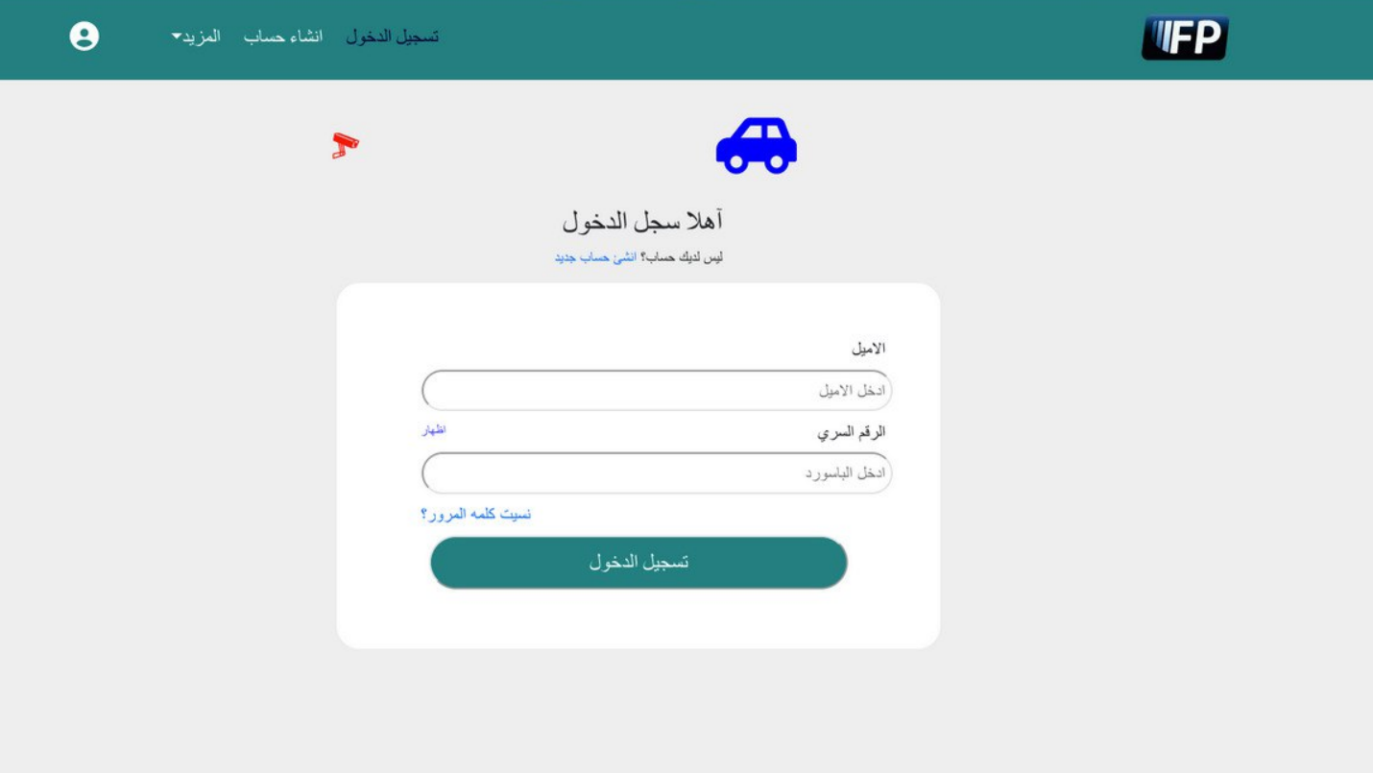

**Login page >> user can log in to the site by Email and password**

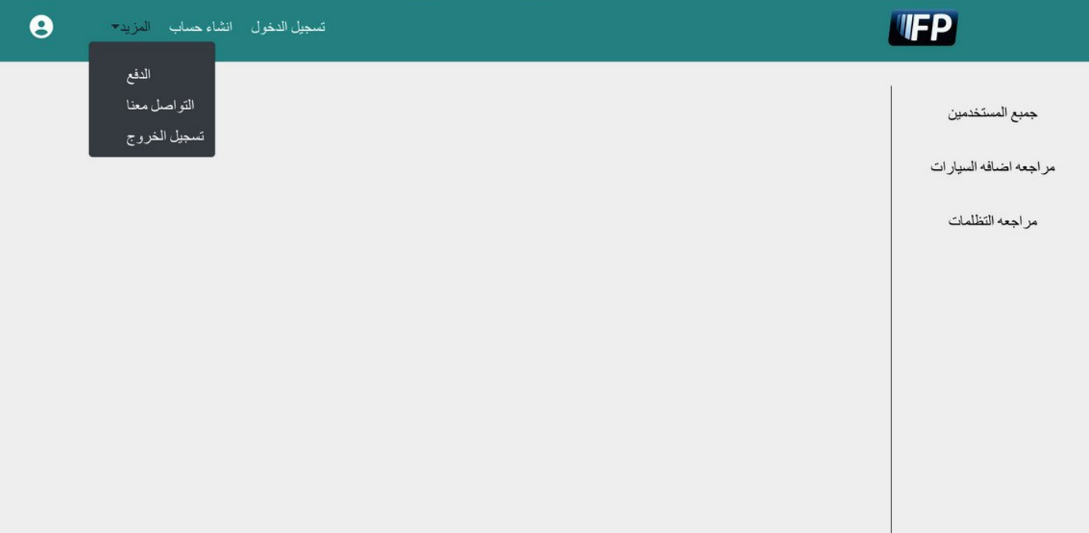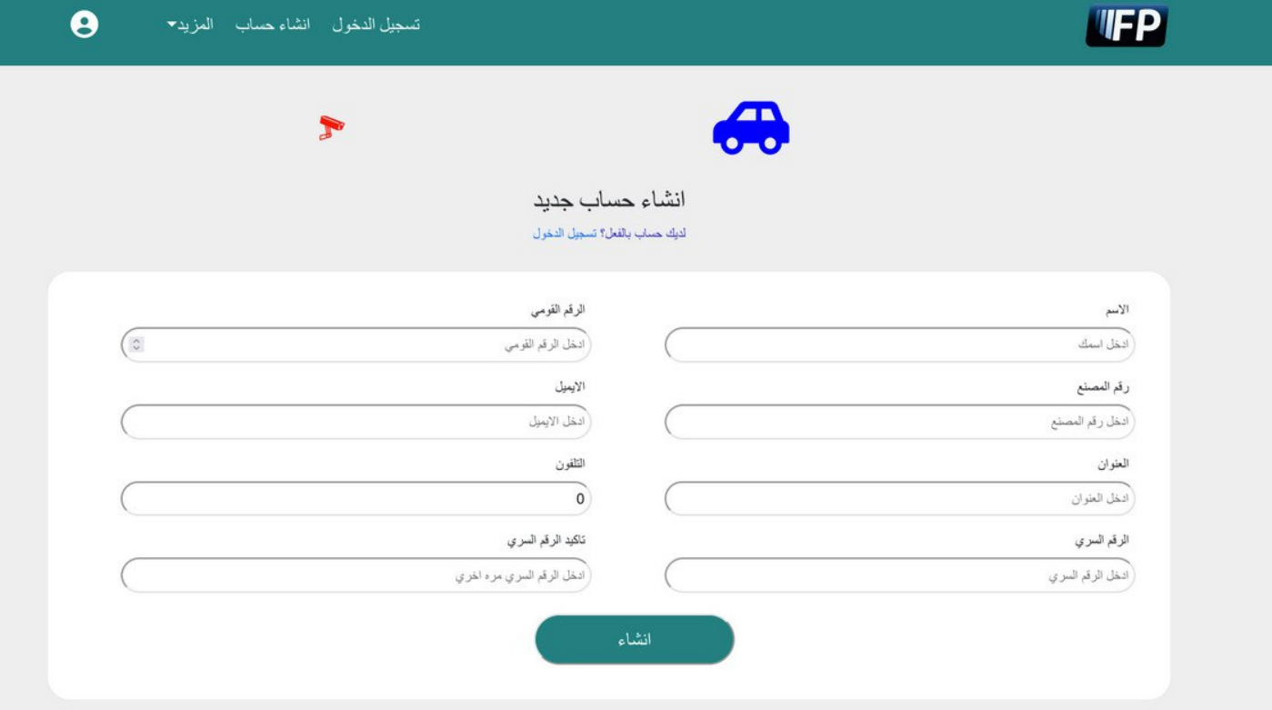**Sign up page >> Add a new account for the user**

**Admin profile page >> Show all users/Review the car addition /ٌReview grievances**

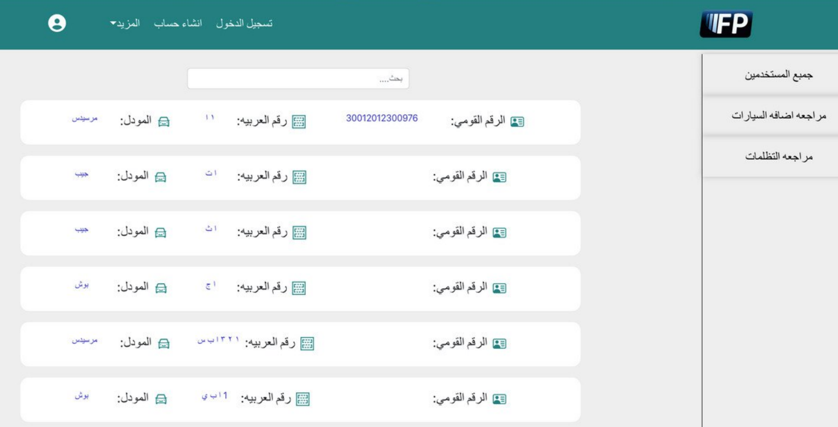

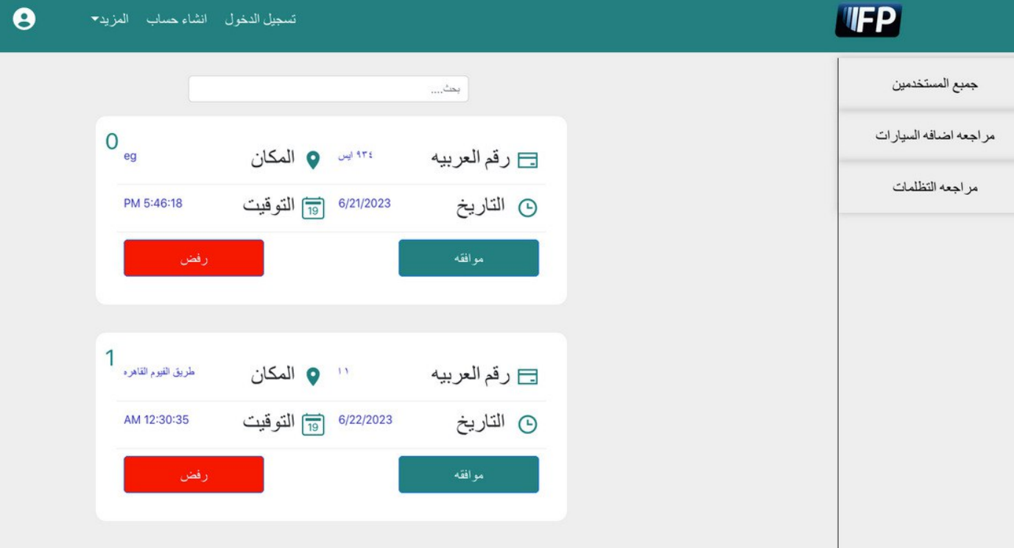Review the car addition page >> Admin approval or not

**Review grievances for user>> Admin approval or not**

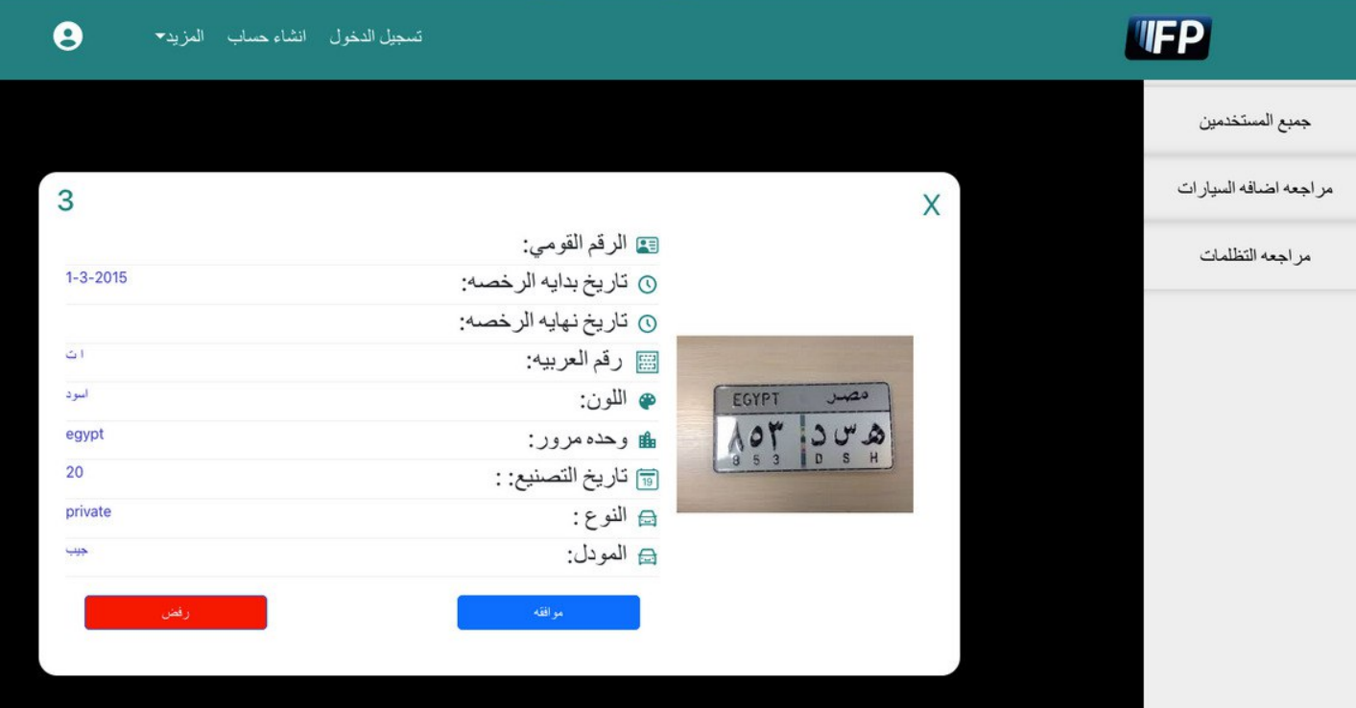

**More details about a car when admin decide to approve or not**

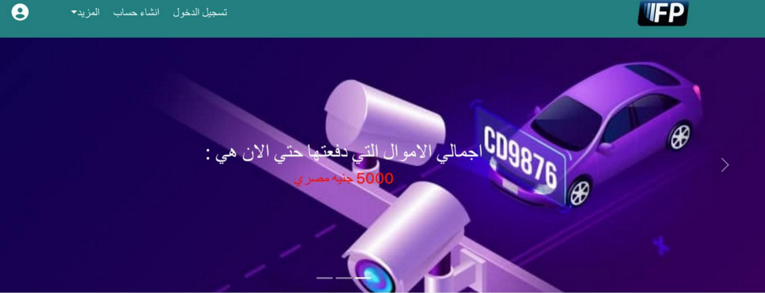

**Show total money that user payed**

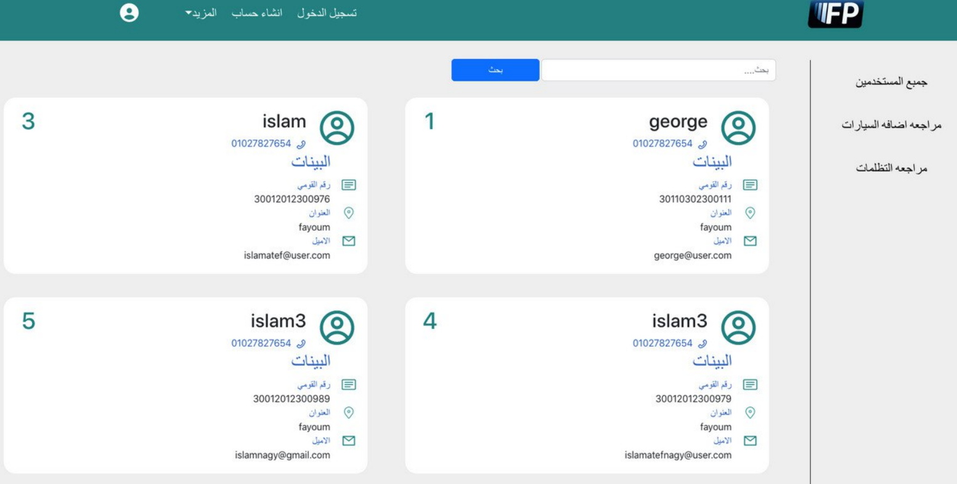

**All users page**

**>> Show all users to the admin**

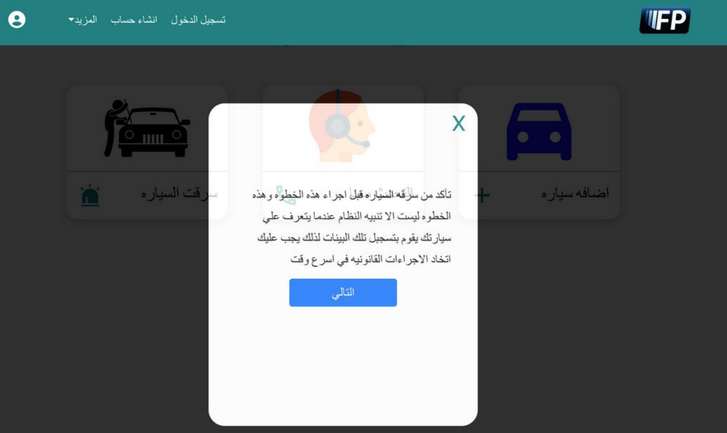

**Warning before report on stolen car**

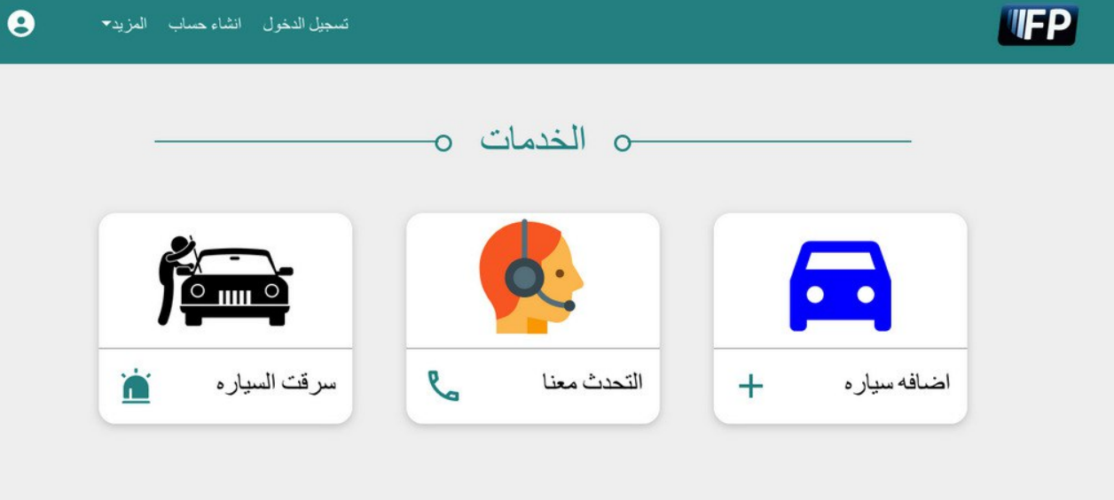

**All services >> contain add car /call us /stolen car**

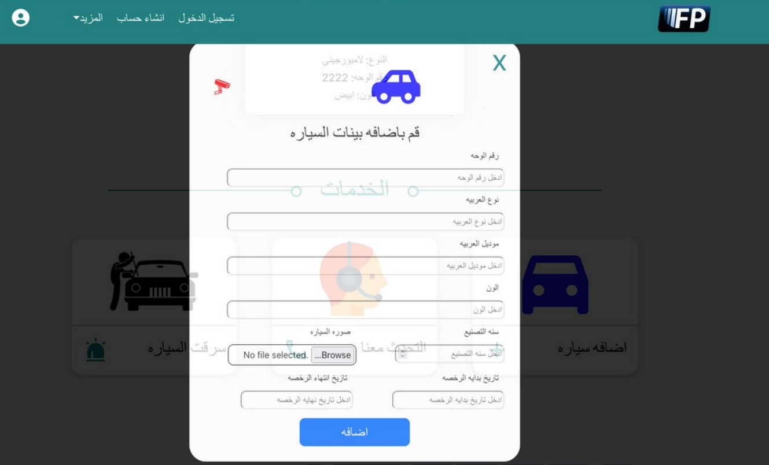

**New Car page**

**>> We can add a new car**

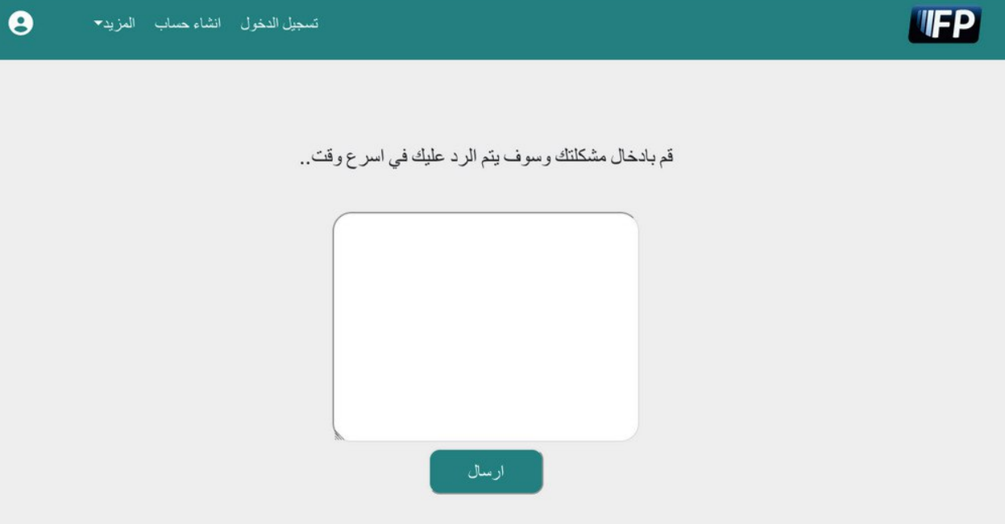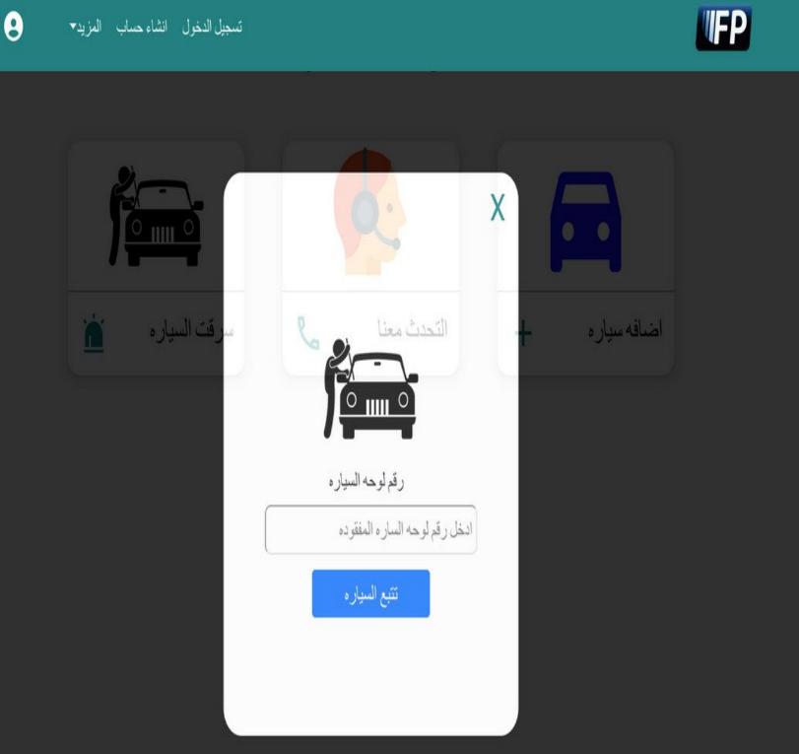 **Call us page stolen car page**

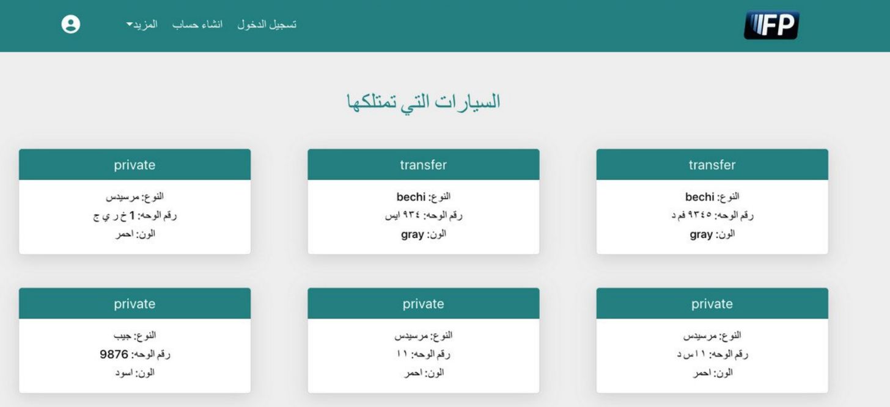

**User cars page**

**>> Show all cars owned by the user**

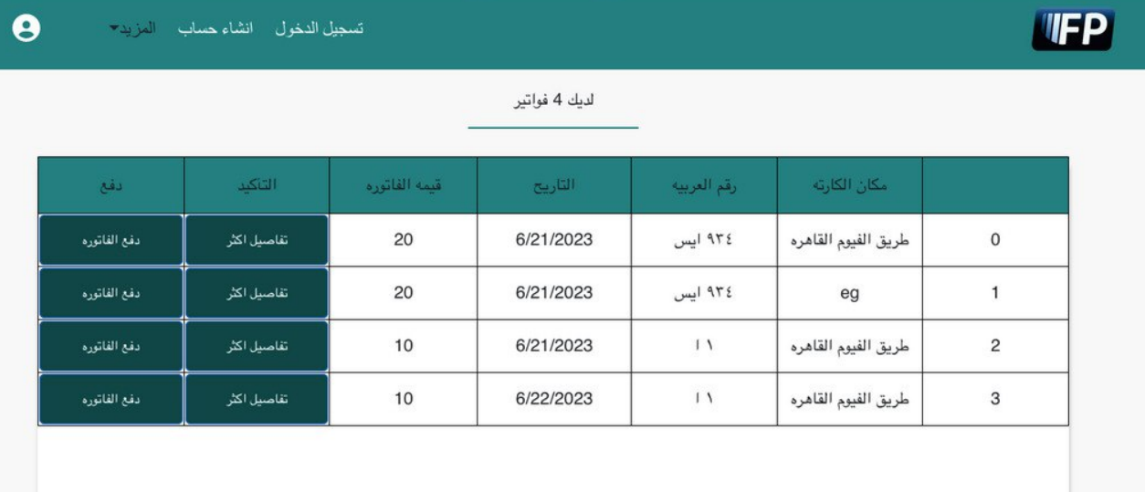

**User Bills page >> contains all Bills of the car**

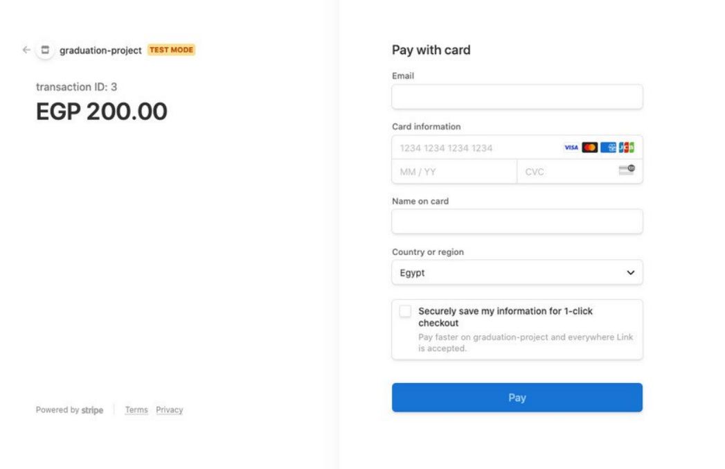**User payment >> user can pay fines**

**7.2 mobile application forms**

**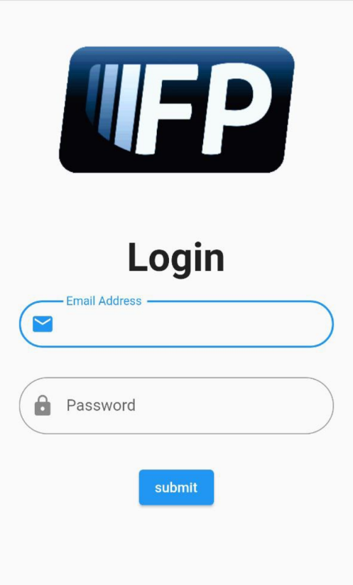*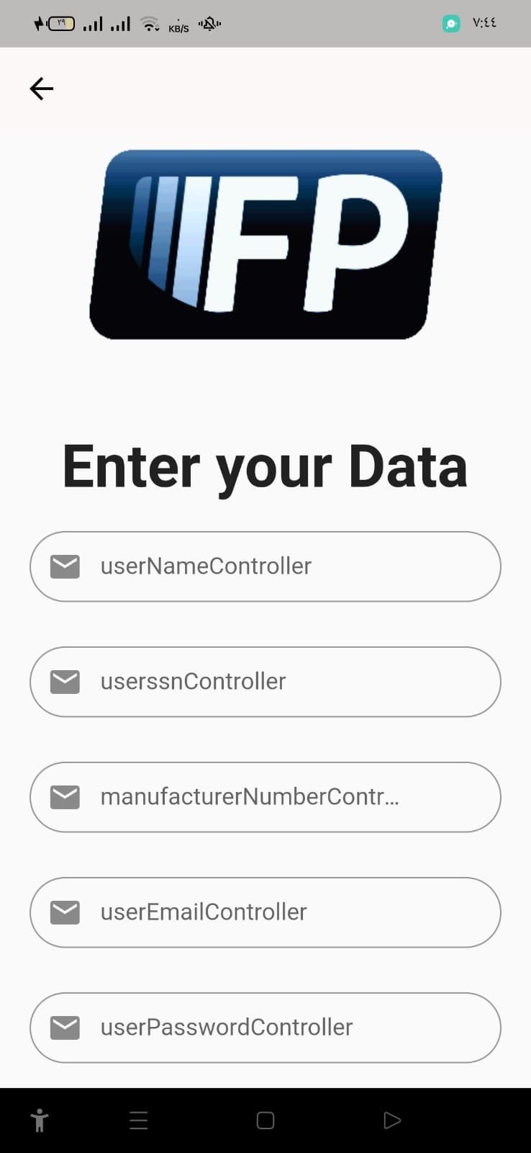***

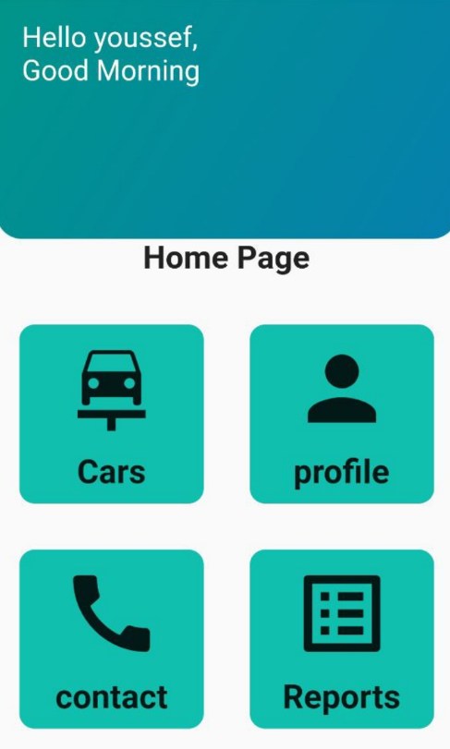 **Sign up page Login page**

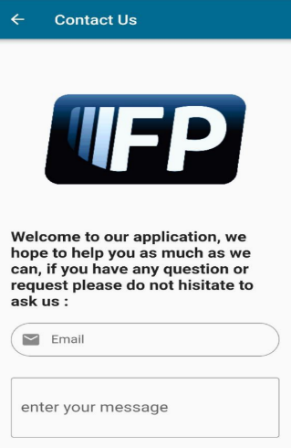

**Home page >> add car/profile/contact / Reports Contact Us page**

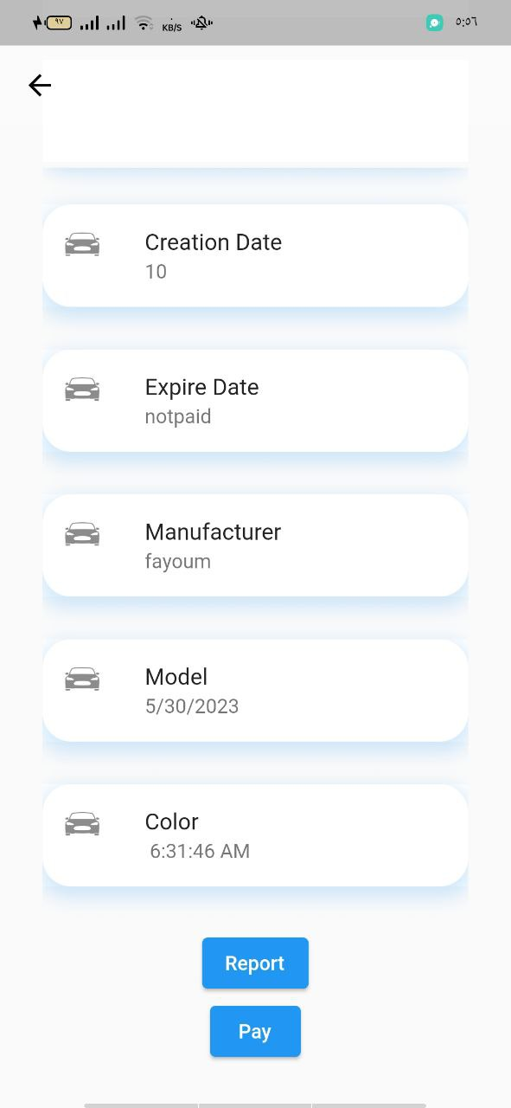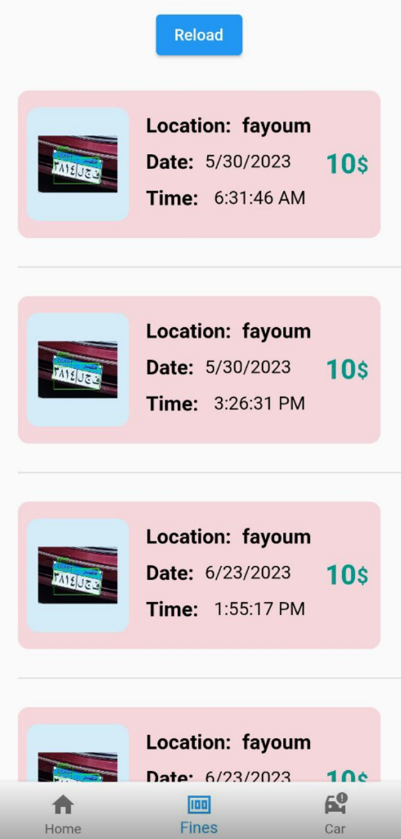

**Fines page Transaction page>> Show all transaction details**

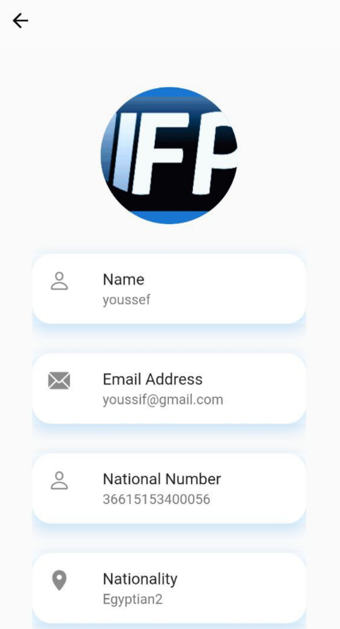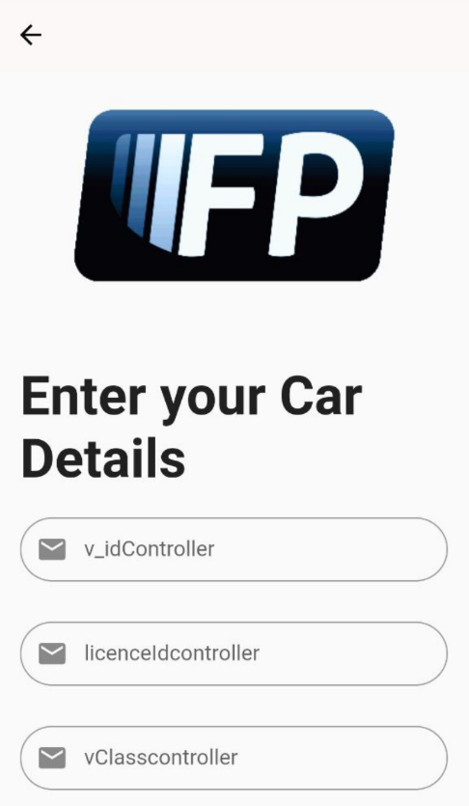

**Cars page >> add car details Profile page >> all info about user**

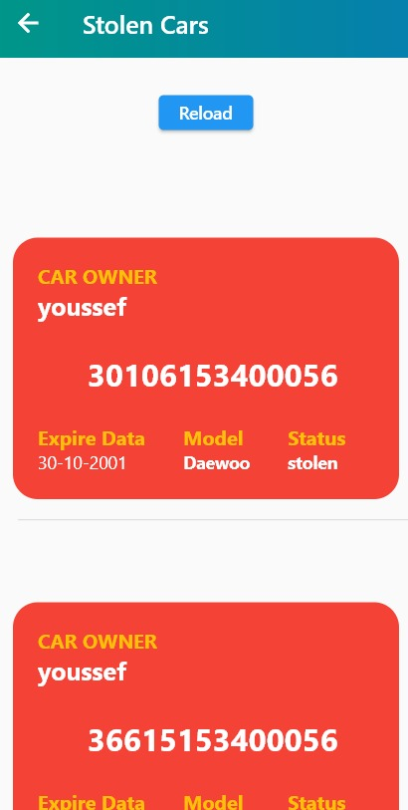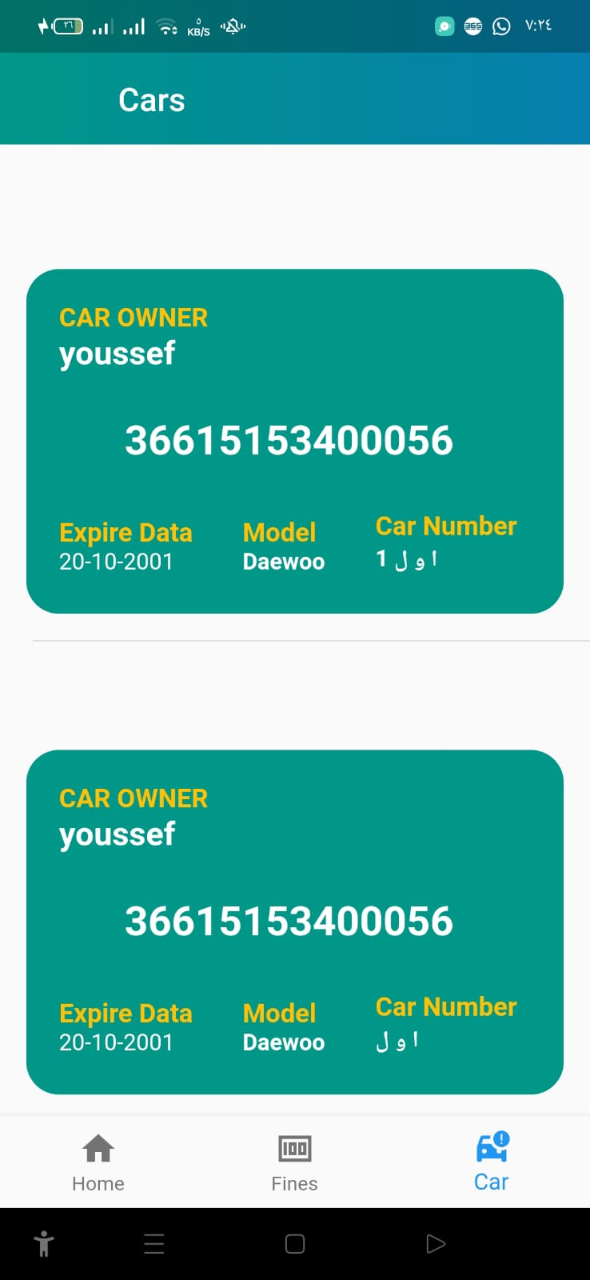

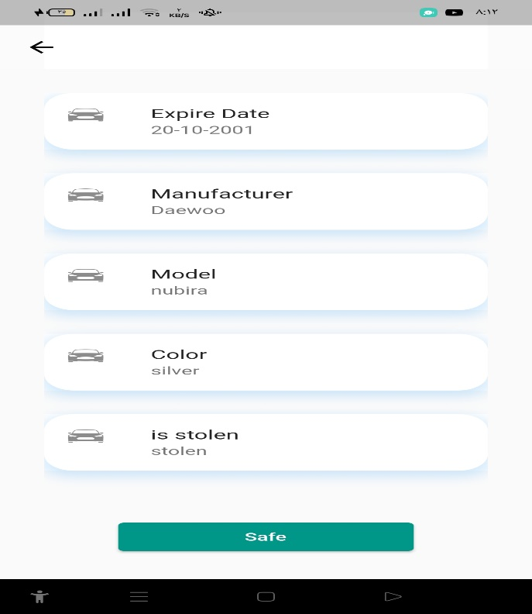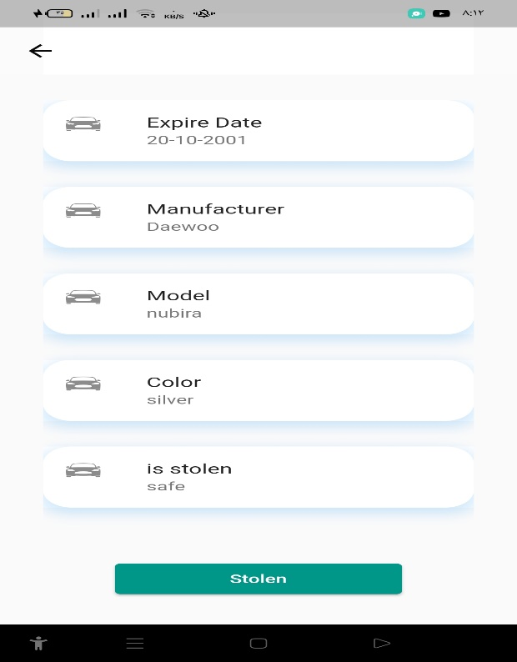 **Stolen Cars page show all user cars**

**Make car is stolen make car is returned**

**References:**

1. [-Ahmed, Ahmed Abdelmoamen, and Sheikh Ahmed. "A Real-Time Car Towing Management System Using ML-Powered Automatic Number Plate Recognition." *Algorithms* 14.11 (2021): 317.‏](https://www.mdpi.com/1999-4893/14/11/317)
2. [-Hassan, Aeyman M., Sami A. Ghoul, and Aya A. Alkabir. "Libyan Vehicle License Plate Recognition with Support Vector Machine." *Al-Mukhtar Journal of Sciences* 37.1 (2022): 1-13.‏](https://omu.edu.ly/journals/index.php/mjsc/article/view/525)
3. [-Antar, Rayana, et al. "Automatic Number Plate Recognition of Saudi License Car Plates." *Engineering, Technology & Applied Science Research* 12.2 (2022): 8266-8272.‏](https://www.etasr.com/index.php/ETASR/article/view/4727)
4. [-Yaacob, N. Liyana, et al. "License plate recognition for campus auto-gate system." *Indonesian Journal of Electrical Engineering and Computer Science* 21.1 (2021): 128-136.‏](https://d1wqtxts1xzle7.cloudfront.net/81735078/14518-libre.pdf?1646453585=&response-content-disposition=inline%3B+filename%3DLicense_plate_recognition_for_campus_aut.pdf&Expires=1674145129&Signature=bQ22TdXryrnvHuqX1HwY7BtuHe821mcUetE8YYNRF9LieFc4VO5vwlEY5loRJabl5JesZdr47HWFntTqT4UjbnRSbSexuXv-sCPcwYcxlQUkpCasy5Cn-8vtXRUj9-EvcfqGfZb2dYyqDEjeAeq4-KvRta87MoNcCUvokYWc-tSPKGjBkWrkHC0b38rfIphGymZWgzucJUu7AixtFt4d45KsHUgaedt-VeL1qsIryNHdJFS5i8cjKO4biC004gLP4~YFsylIRAJdDVKswzTQYboTQyyf-Tu6epxERQGxVKd2ArL6c68luzX9yeD~tC5AapJYDkaSxGSqQaEW0BC1Ag__&Key-Pair-Id=APKAJLOHF5GGSLRBV4ZA)
5. [-Alizadeh, Fattah, and Sazan Luqman. "A Novel Approach for Automatic Car Plate Detection and Recognition." *UKH Journal of Science and Engineering* 5.2 (2021): 1-9.‏](https://journals.ukh.edu.krd/index.php/ukhjse/article/view/196)
6. [-Pugalenthy, Kuken Raj, et al. "Malaysian Vehicle License Plate Recognition Using Deep Learning and Computer Vision." *Proceedings of the 6th International Conference on Electrical, Control and Computer Engineering*. Springer, Singapore, 2022.‏](https://link.springer.com/chapter/10.1007/978-981-16-8690-0_88)
7. [-Tham, Mau-Luen, and Wei Kun Tan. "IoT Based License Plate Recognition System Using Deep Learning and OpenVINO." *2021 4th International Conference on Sensors, Signal and Image Processing*. 2021.‏](https://dl.acm.org/doi/abs/10.1145/3502814.3502816)
8. [-Saidani, Taoufik, and Yamen El Touati. "A vehicle plate recognition system based on deep learning algorithms." *Multimedia Tools and Applications* 80.30 (2021): 36237-36248.‏](https://link.springer.com/article/10.1007/s11042-021-11233-z)
9. [-Silva, Sergio M., and Cláudio Rosito Jung. "A flexible approach for automatic license plate recognition in unconstrained scenarios." *IEEE Transactions on Intelligent Transportation Systems* (2021).‏](https://ieeexplore.ieee.org/abstract/document/9357409)